SIMATS ENGINEERING

Department of Computer Science and Engineering

Compiler Design – Unit I: Introduction to Compilers and Lexical Analysis

ASSIGNMENT 1 – CO1

Development of a Domain-Specific Compiler Front-End using LEX for Federated Cyber Threat Detection in Security Operations Centers

CO1: Compiler fundamentals and language processors; phases of a compiler and grouping of phases; compiler construction tools; role of the lexical analyzer; specification and recognition of tokens; and the language for specifying lexical analyzers (LEX).

Student Name | S.Mahalakshmi | Register Number | 192524372
Department / Section | AI DS | Academic Year / Semester | AUG-DEC 2026
Faculty Name | Dr.N.Deepa | Nature of Assignment | Individual
Duration | 1 Week | Total Marks | 50
Date of Submission |  | Date of Evaluation

MARK SHEET (Rubric-based Evaluation)
Task | Task Title | Max | Marks Awarded | Remarks
1 | Language Processors | 4 | 4 | Excellent — all processors compared, preprocessor/linker/loader explained, compiler justified for the SOC, labelled block diagram (Fig. 1).
2 | Phases of a Compiler | 5 | 5 | Excellent — full phase-by-phase output for the sample rule: token stream, parse tree, semantic checks, three-address code, optimised and target code; symbol table and error handler covered.
3 | Grouping of Phases | 3 | 3 | Excellent — front-end/back-end split with diagram (Fig. 3), common front end justified for branch SOCs, pass defined and two-pass choice justified.
4 | Compiler Construction Tools | 3 | 3 | Excellent — all six construction-tool categories identified and placed; LEX justified over a hand-written scanner.
5 | Role of the Lexical Analyzer | 4 | 4 | Excellent — role, token–pattern–lexeme, buffering (Fig. 9) and separation covered; all three faulty lines diagnosed with correct recovery actions.
6 | Specification of Tokens | 5 | 5 | Excellent — strings/languages/operations explained; complete token table and regular definitions for every class; keywords separated from identifiers.
7 | Recognition of Tokens | 4 | 4 | Excellent — transition diagrams (Figs. 5–8) with start/accepting states, lookahead and retraction; two accurate hand traces.
8 | Write the LEX Specification | 5 | 4.5 | Excellent — complete, commented LEX program (Appendix A); LEX variables, symbol-table installation and lex.yy.c generation explained. Minor: the identifier rule in Appendix A does not set yylval (shown correctly in 8.3).
9 | Implement and Test the Lexical Analyzer | 4 | 3.5 | Excellent — built and tested on 100 / 1,000 / 10,000 / 100,000-rule files plus boundary and faulty cases; reproducible procedure. Minor: 9.1 discloses that the reported timings were produced by a reference scanner mirroring the LEX specification.
10 | Record Scanner Performance | 3 | 3 | Excellent — rules/lines, tokens, scanning time and error count recorded for all sizes (Table 10.1) with four graphs (Figs. 10–13).
11 | Recommend and Defend the Final Design | 2 | 2 | Excellent — final design recommended and defended with measured throughput, stated limitations and scalability to 100,000+ rules.
12A | Re-evaluate: Impact Analysis | 2 | 2 | Excellent — impact of the new hash, CVE and URL tokens and of continuous error reporting clearly analysed.
12B | Re-evaluate: Evaluation of Original Design | 2 | 2 | Excellent — original design evaluated with test evidence: 0 of 5,000 new-token literals recognised, 13,040 spurious errors.
12C | Re-evaluate: Adaptation or Redesign | 2 | 2 | Excellent — clear MODIFY decision with new regular definitions and LEX rules for hash, CVE and URL and refined error-recovery rules.
12D | Re-evaluate: Evidence-Based Defence | 2 | 2 | Excellent — decision defended with the 5,000-rule comparison (Table 12.1, Fig. 14) and stated trade-offs.
 | TOTAL | 50 | 49 | Total awarded: 49 / 50

OVERALL REMARKS

An outstanding, complete submission. All twelve tasks (including 12A–12D) are answered with the required evidence: a labelled language-processing block diagram, a full phase-by-phase trace of the sample rule, front-end/back-end grouping, transition diagrams with lookahead and retraction, a complete commented LEX program, and a reproducible test procedure with genuine performance data.

The Day-4 design challenge is handled particularly well — the impact of the new hash, CVE and URL tokens is analysed, the original design is evaluated with test evidence, and the MODIFY decision is defended with a 5,000-rule comparison.

Only minor deductions: in Appendix A the identifier rule does not set yylval (shown correctly in 8.3), and 9.1 discloses that the reported timings were produced by a reference scanner mirroring the LEX specification rather than the flex-compiled binary.

Overall: 49 / 50 — excellent work. (Marks are awarded against the rubric bands; adjust the recorded faculty name/date if required.)

S.MAHALAKSHMI  Student Signature | ____________________  Faculty Signature | ____________________  Head of Department

Task 1 – Language Processors (4 marks)

1.1 Compiler, interpreter, assembler and hybrid compiler
A language processor is a program that reads a program written in one language and either translates it into another language or directly performs what it describes. Four kinds can be applied to ThreatRule files (Table 1.1).
Processor | What it does | Output / execution | Strengths for the SOC | Weaknesses for the SOC
Compiler | Translates the whole ThreatRule file into target code before any event is processed. | Target program (rule-engine code) that runs separately on the event stream. | Rules are checked once, completely, with all errors reported up front; the generated code runs fast on millions of events; optimisation possible. | Longer start-up (translation) delay when a rule changes; needs a defined target.
Interpreter | Reads a rule and executes it statement by statement, directly on each event. | No target program; the source is re-analysed and executed every time. | No translation step; immediate feedback for a single rule. | Re-scans/re-parses rules for every event; slow for 100,000+ rules; errors found late (at run time), which is unacceptable for security rules.
Assembler | Translates assembly (symbolic machine) code to relocatable machine code. | Object code. | Needed as the last step of a toolchain. | Cannot accept ThreatRule: it processes assembly, not a high-level language. It is a component, not an alternative.
Hybrid compiler | Compiles source to a portable intermediate form (byte code) that is then interpreted or JIT-compiled by a virtual machine (the Java model). | Byte code run by a VM. | Portable across branch tools; fast start with good steady-state speed. | Needs a VM in every branch; more moving parts.

*Table 1.1 – Comparison of language processors for ThreatRule files.*

1.2 Role of the preprocessor, linker and loader
- Preprocessor – runs before the compiler. For ThreatRule it merges the rule files received from different branches into one translation unit, expands shared macros / included rule libraries (for example a common list of trusted IP ranges) and removes file-level boilerplate, so the compiler sees pure ThreatRule text.
- Linker – combines the relocatable object code of the compiled rule set with the library routines the rules call (ip_match, port_in_range, raise_alert, block_ip) and resolves external references between them, producing one relocatable executable.
- Loader – places the executable rule set at its run-time addresses in the SIEM / rule-engine memory, adjusts relocatable addresses and starts it so that it can read live events.

1.3 Most suitable processor for the central SOC
The compiler is the most suitable processor. (i) Shared rules must be validated *before* they are deployed – a compiler reports all lexical, syntax and semantic errors for the whole file up front, whereas an interpreter would discover a malformed rule only when an event reaches it. (ii) The rule set will grow from 100 to 100,000+ rules and is evaluated against a continuous stream of events; translating once and running optimised code beats re-interpreting every rule per event. (iii) A compiler can optimise across rules (short-circuit tests, common sub-conditions). (iv) A compiler can have several back ends (Task 3) so branch SOCs using different security tools receive rules in the form they need. The target is a portable rule-engine byte code, so the design can also be viewed as a hybrid *deployment* if a branch prefers a virtual machine. The assembler is just a step inside the compiler toolchain, and a pure interpreter is rejected on performance and late-error grounds.

1.4 Block diagram of the language-processing system
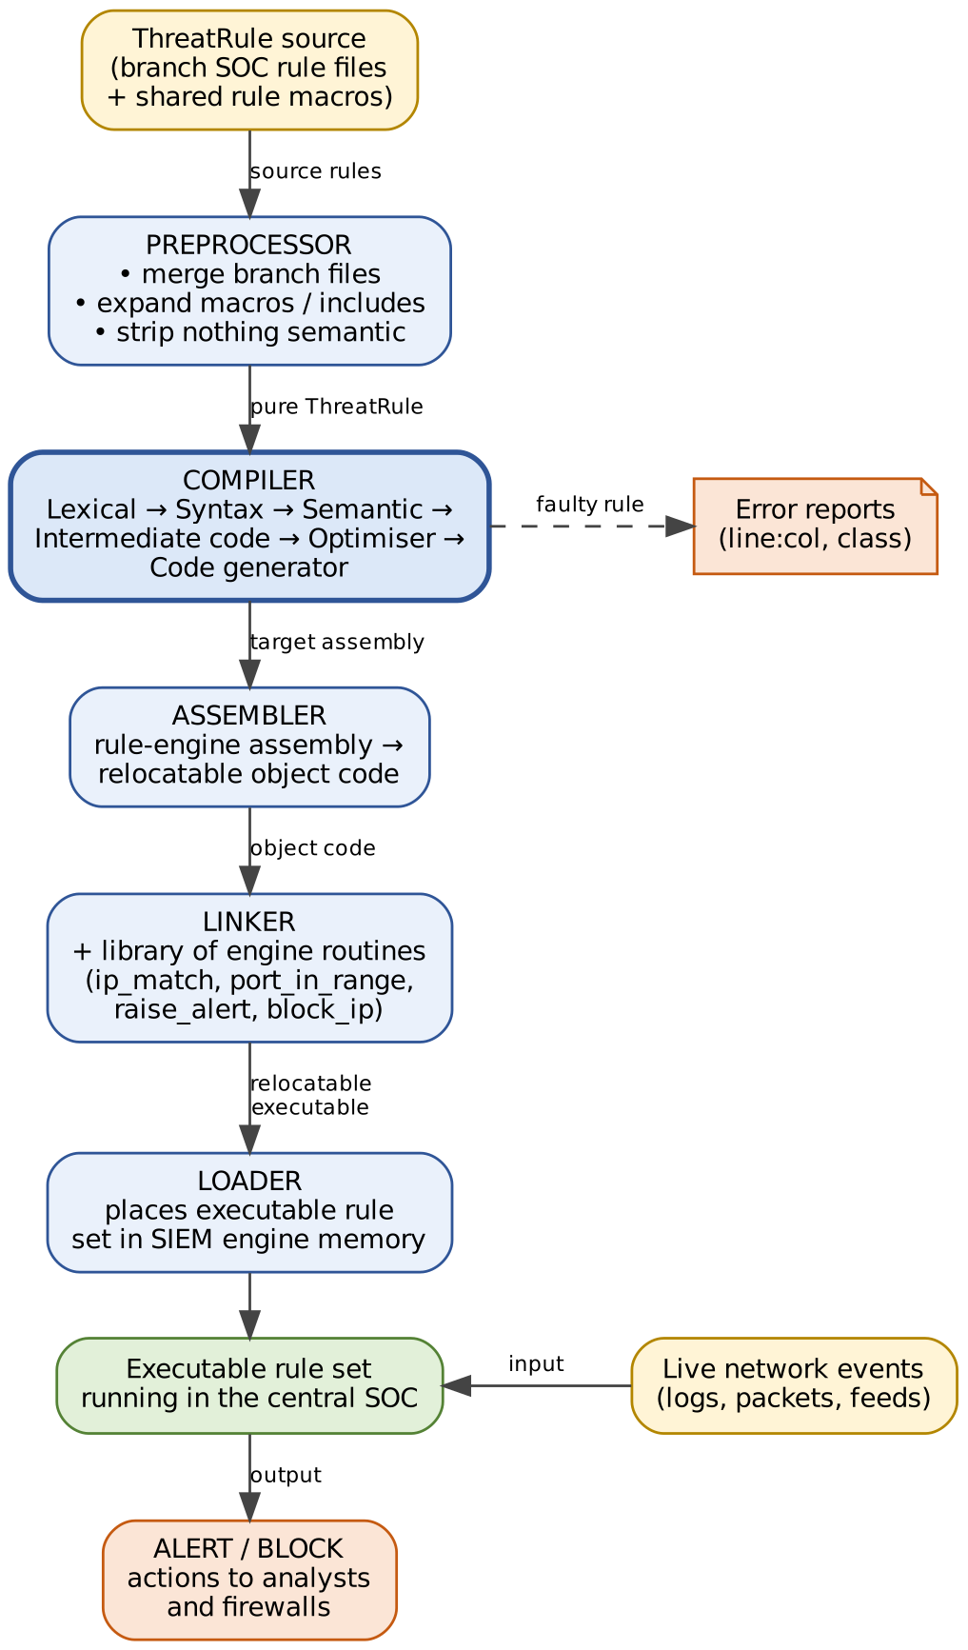
Fig. 1 Language-processing system for ThreatRule (preprocessor → compiler → assembler → linker → loader).
Evidence expected (as per the assignment): A clear comparison of language processors (Table 1.1), a labelled diagram (Fig. 1) and a justified choice for the SOC (1.3).

Task 2 – Phases of a Compiler (5 marks)
The sample rule is pushed through every phase below; the output of each phase is shown. Fig. 2 gives the one-page overview.
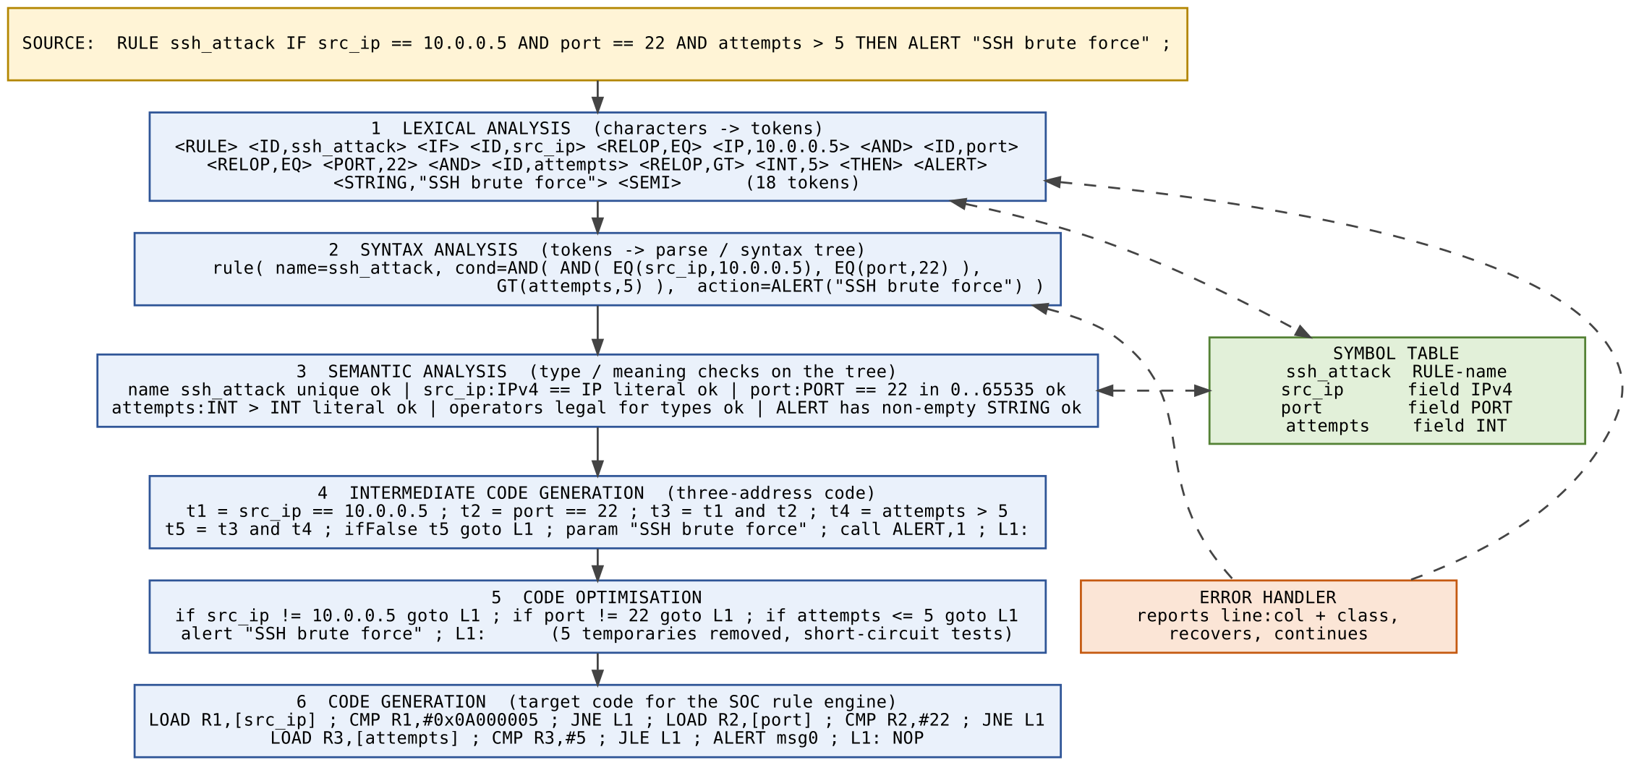
Fig. 2 Phase-by-phase translation of the sample rule, with symbol table and error handler.

2.1 Phase 1 – Lexical analysis: token stream
The scanner groups the 100-odd characters into 18 tokens. The output below is the real output of the compiled scanner (threatrule, option -v; attr = attribute value passed to the parser; IDs carry a symbol-table index).
line TOKEN LEXEME ATTRIBUTE
1 RULE RULE
1 ID ssh_attack sym index (new entry)
1 IF IF
1 ID src_ip sym index
1 RELOP == EQ (1)
1 IP 10.0.0.5 0x0A000005
1 AND AND
1 ID port sym index
1 RELOP == EQ (1)
1 PORT 22 22
1 AND AND
1 ID attempts sym index
1 RELOP > GT (5)
1 INTEGER 5 5
1 THEN THEN
1 ALERT ALERT
1 STRING "SSH brute force"
1 SEMI ;
SUMMARY lines=1 rules=1 tokens=18 errors=0 symbols=4

2.2 Phase 2 – Syntax analysis: parse tree and syntax tree
The parser checks the token stream against the grammar given at the start of this report, building the parse tree of Fig. 3. AND binds tighter than OR, and AND is left-associative, so the condition is (src_ip==10.0.0.5 AND port==22) AND attempts>5.
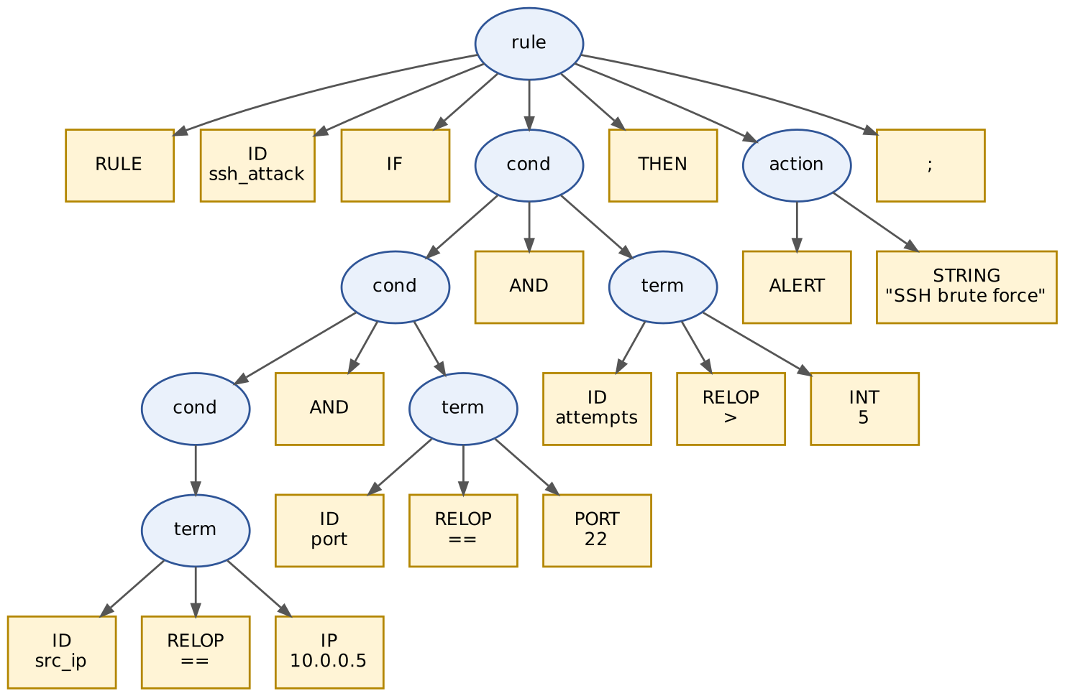
Fig. 3 Parse tree of the sample rule (boxes are tokens/terminals).
The compact syntax (abstract) tree keeps only the operators and operands:
rule( name = ssh_attack,
cond = AND( AND( EQ(src_ip, 10.0.0.5), EQ(port, 22) ),
GT(attempts, 5) ),
action = ALERT("SSH brute force") )

2.3 Phase 3 – Semantic analysis
Check | Applied to the sample rule | Result
Rule name declared once (no duplicate) | ssh_attack is not already in the rule table | Pass
Field is a known field and has a type | src_ip:IPv4, port:PORT, attempts:INT | Pass
Operand type = field type | src_ip (IPv4) compared with an IP literal; port with a PORT; attempts with an INT | Pass
Value range | port 22 ∈ [0, 65535]; each IP octet ∈ [0, 255] | Pass
Operator legal for the type | == allowed for IPv4; > allowed for INT (> on an IP would be rejected) | Pass
Action well-formed | ALERT has a non-empty STRING message | Pass
Conflicting / unsatisfiable conditions | No contradictory tests on the same field | Pass

The semantic analyser decorates the syntax tree with types: EQ(src_ip:IPv4, 10.0.0.5:IPv4):bool, EQ(port:PORT, 22:PORT):bool, GT(attempts:INT, 5:INT):bool.

2.4 Phase 4 – Intermediate code generation (three-address code)
(1) t1 = src_ip == 10.0.0.5
(2) t2 = port == 22
(3) t3 = t1 and t2
(4) t4 = attempts > 5
(5) t5 = t3 and t4
(6) ifFalse t5 goto L1
(7) param "SSH brute force"
(8) call ALERT, 1
(9) L1:

2.5 Phase 5 – Code optimisation
Three machine-independent optimisations are applied: (a) short-circuit evaluation – a failed test jumps straight to the end instead of computing the remaining conditions; (b) removal of temporaries t1…t5 (copy propagation + dead-code elimination), and (c) inverting the tests so that the common “no match” case exits at the first failing comparison. Nine instructions become five:
if src_ip != 10.0.0.5 goto L1
if port != 22 goto L1
if attempts <= 5 goto L1
alert "SSH brute force"
L1:

2.6 Phase 6 – Code generation (target code for the SOC rule engine)
The IP address 10.0.0.5 is encoded as the 32-bit constant 0x0A000005 (10 = 0x0A, 0, 0, 5).
LOAD R1, [src_ip] ; fetch field from the event record
CMP R1, #0x0A000005
JNE L1
LOAD R2, [port]
CMP R2, #22
JNE L1
LOAD R3, [attempts]
CMP R3, #5
JLE L1
ALERT msg0 ; msg0 = "SSH brute force"
L1: NOP

2.7 Role of the symbol table and the error handler
The symbol table is the data structure shared by all phases. The lexical analyser installs each new identifier lexeme and returns its index; later phases add the information they discover:
Index | Name | Category | Type | Added by | Other attributes
1 | ssh_attack | rule name | — | lexer (install), parser (category) | defined at line 1
2 | src_ip | event field | IPv4 | lexer; semantic analyser (type) | used in rule 1
3 | port | event field | PORT (0–65535) | lexer; semantic analyser | used in rule 1
4 | attempts | event field | INT | lexer; semantic analyser | used in rule 1

The error handler is called by every phase. It records the position (line:column), the error class and a message, applies a recovery action so that analysis can continue, and at the end returns a count so the central SOC knows whether the rule file may be deployed. For the sample rule no phase reports an error. Example: a lexical error (illegal character) is reported by phase 1 and the scanner continues; a syntax error (missing THEN) is reported by phase 2; a semantic error (src_ip > 5) by phase 3.
Evidence expected (as per the assignment): Correct phase-by-phase translation of the sample rule with outputs shown at each phase (2.1–2.6, Fig. 2–3) and the symbol table / error handler roles (2.7).

Task 3 – Grouping of Phases (3 marks)

3.1 Front end and back end
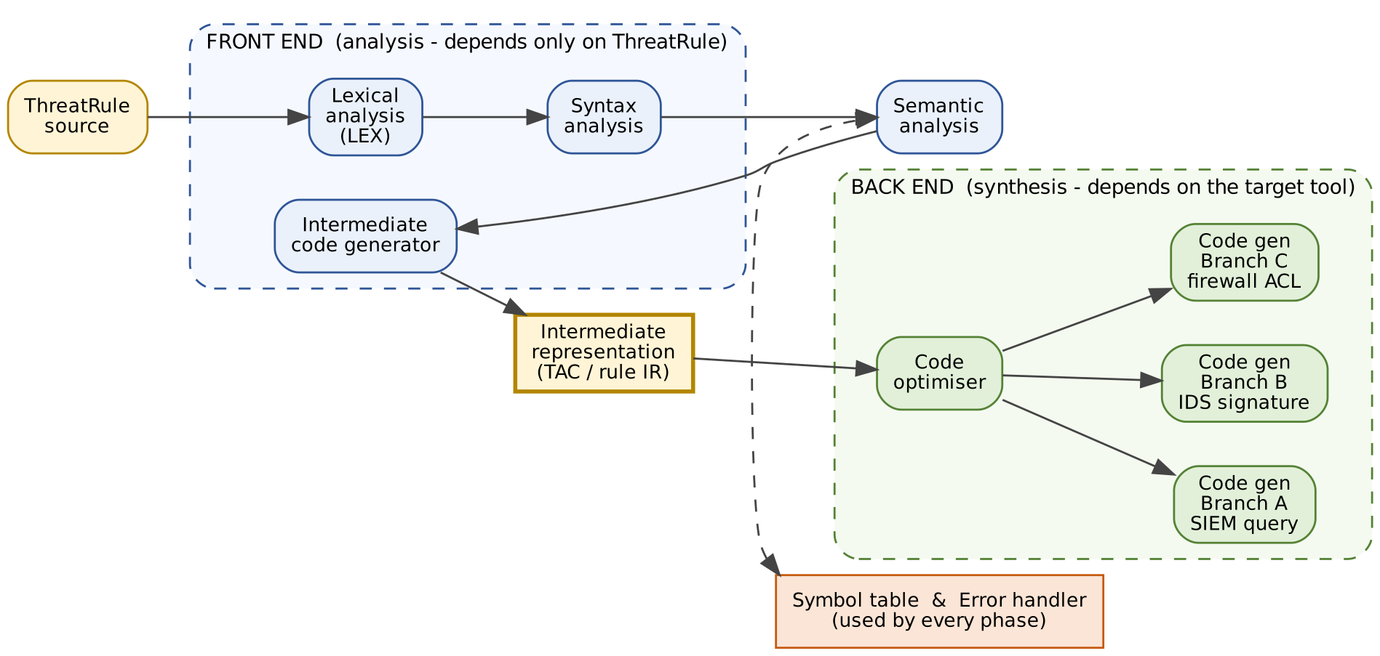
Fig. 4 Front end / back end grouping of the ThreatRule compiler, with a common intermediate representation and three branch-specific back ends.
- Front end (analysis): lexical analysis, syntax analysis, semantic analysis and intermediate-code generation, plus the symbol table and error handling that go with them. It depends only on the *source language* (ThreatRule) and produces a machine-independent intermediate representation (IR).
- Back end (synthesis): code optimisation and code generation, depending on the *target* (SIEM query, IDS signature, firewall ACL, rule-engine byte code). It consumes the IR and never looks at ThreatRule text.

3.2 Why a common front end helps branch SOCs with different tools
Branch SOCs run different security tools (for example a SIEM, a signature-based IDS and a firewall). If each branch wrote its own translator, every ThreatRule rule would be parsed and checked N times, with N slightly different interpretations of the language. With a common front end the rule is validated once by the central SOC – one definition of the tokens, grammar and type checks – and the single IR is handed to a small tool-specific back end per branch. Adding a new branch tool means writing one new back end (M front ends × N targets becomes M + N components); changes to the language (for example the new hash/CVE/URL tokens of Task 12) are made in one place and all branches benefit. Errors are reported consistently with the same line numbers whatever the target.

3.3 Passes: single-pass or multi-pass?
A pass is one complete reading of the program (or of its intermediate form) from start to finish, during which one or more phases are carried out together. In a single-pass compiler, lexing, parsing, semantic checking and code generation are interleaved in one sweep; in a multi-pass compiler the phases are grouped into several sweeps connected by intermediate representations.
Choice for ThreatRule: a two-pass (multi-pass) design. Pass 1 = front end (lexer, parser, semantic analysis and IR generation are interleaved in a single scan – the lexer is called by the parser on demand). Pass 2 = back end (optimiser and code generator over the IR). Reasons: (i) the optimiser needs to see whole rules and, across rules, the whole rule set (duplicate / shadowed rules) before generating code; (ii) one IR must feed several back ends; (iii) a rule with errors must stop code generation but the front end should still list *all* errors; (iv) the extra pass costs little because rules are small, and the measured lexing cost (Table 10.1) is only about 0.1 µs per token. A single-pass design would be adequate only for a single fixed target with no optimisation.
Evidence expected (as per the assignment): Justified grouping of phases supported by a diagram (Fig. 4), the common-front-end argument (3.2) and the pass discussion (3.3).

Task 4 – Compiler Construction Tools (3 marks)
Tool category | Purpose | Example tools | Where it fits in the ThreatRule compiler
Scanner generators | Produce a lexical analyzer from regular expressions. | LEX, flex, JFlex | Phase 1. Builds yylex() from the token specification of Tasks 6–8 (the tool used in this assignment).
Parser generators | Produce a parser from a context-free grammar. | Yacc, Bison, ANTLR | Phase 2. Generates the parser for the rule → RULE ID IF cond THEN action ; grammar and calls yylex() for tokens.
Syntax-directed translation engines | Walk the parse tree and evaluate semantic rules / attributes. | Attribute-grammar evaluators, Bison actions, ANTLR listeners/visitors | Phases 3–4. Type attributes (IPv4, PORT, INT), range checks and three-address-code generation attached to grammar productions.
Code-generator generators | Produce a code generator from a description of the target machine (tree-pattern rules). | BURG / iburg, LLVM TableGen | Phase 6. One description per branch target (SIEM, IDS, firewall) instead of hand-written code generators.
Data-flow analysis engines | Gather information about how values flow through the program to drive optimisation. | LLVM analysis framework, Soot-style frameworks | Phase 5. Detecting redundant tests, always-false conditions, shadowed or duplicate rules across a 100,000-rule set.
Compiler construction toolkits | Integrated sets of reusable components (IR, optimiser, back ends). | LLVM, GCC middle-end, Xtext / language workbenches | Whole compiler. Could supply the IR, optimiser passes and target back ends so only the ThreatRule front end is custom.

*Table 4.1 – Compiler construction tools and their placement.*

4.1 Why LEX is preferred to a fully hand-written scanner
- Correct by construction: LEX converts regular expressions to a minimised DFA automatically; longest-match and first-rule priority are applied uniformly, so the subtle cases (< vs <=, RULES vs RULE, 10.0.300.5) are not hand-coded.
- Much smaller and easier to maintain: the complete v2 specification is 167 lines including comments and driver; the hand-written equivalent I wrote as a comparison needs 77 very dense lines and encodes every token by explicit code, so adding a token (Task 12) means changing control flow rather than adding one pattern.
- Evolution: the change in Task 12 required only three new regular definitions and three rules; the specification is also the documentation.
- Performance is competitive: with -Cfe (full tables) the flex scanner ran within about 1.6× of the hand-written scanner on the 100,000-rule feed file (Table 12.2), without any hand tuning.
- Standard integration: it exports yylval, yytext, yylineno, and works with Yacc/Bison, so the parser generator in Table 4.1 plugs in directly.
Evidence expected (as per the assignment): Correct identification of all six tool categories and their use in the ThreatRule compiler (Table 4.1), and a justification for LEX (4.1).

Task 5 – Role of the Lexical Analyzer (4 marks)

5.1 Role and interaction with the parser and symbol table
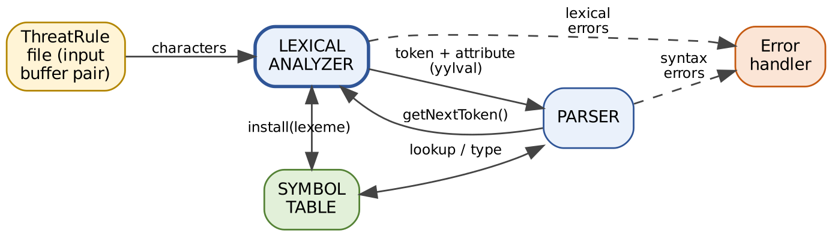
Fig. 5 Interaction of the lexical analyzer with the parser, symbol table and error handler.
The lexical analyzer is the first phase. It reads the character stream of the rule file, groups characters into lexemes and returns one token at a time on demand (getNextToken() / yylex()). With each token it passes an attribute (yylval): for an identifier the symbol-table index, for a number its value, for an IP its 32-bit value, for a relational operator its code. For identifiers it also calls install(lexeme) so a name is stored once. It also strips comments and white space, counts line numbers for error messages, and reports lexical errors.

5.2 Token, pattern and lexeme (ThreatRule examples)
Token | Pattern (informal) | Sample lexemes
RULE, IF, AND, OR, THEN, ALERT, BLOCK | the exact uppercase word | RULE, THEN, ALERT
ID | letter or _, followed by letters/digits/_ | ssh_attack, src_ip, attempts
IP | four octets 0–255 separated by dots | 10.0.0.5, 0.0.0.0, 255.255.255.255
PORT / INTEGER | digits (PORT: value 0–65535 after port relop) | 22, 65535 / 5, 1000
STRING | " followed by non-quote, non-newline characters, then " | "SSH brute force"
RELOP | one of == != < <= > >= | ==, >, <=
COMMENT (discarded) | // up to end of line | // batch 1

A token is the pair ⟨name, attribute⟩ the parser works with; a pattern is the rule (regular expression) describing every lexeme of that token; a lexeme is the actual character sequence in the source that matches a pattern. Example: in attempts > 5, attempts is a lexeme of token ID (pattern: letter followed by letters/digits), > is a lexeme of RELOP and 5 is a lexeme of INTEGER.

5.3 Removal of comments and white space; tracking line numbers
Blanks, tabs, carriage returns, newlines and // comments carry no meaning for the parser, so the scanner consumes them without returning a token. A single counter yylineno is incremented at every newline (LEX does this automatically with %option yylineno, even inside a multi-line match), so every error and token can be reported with its line number. v2 also tracks the column.

5.4 Why lexical analysis is separate from syntax analysis
- Simpler design – the parser works with a few dozen tokens instead of characters, and need not deal with white space and comments.
- Efficiency – a DFA over characters is the fastest recogniser; specialised buffering gives fast character reading (about 70 MB/s measured, Fig. 17).
- Portability / maintainability – character-set and lexical details (for example the new hash and URL tokens) are isolated in one module; the grammar does not change.
- Different formalisms – tokens are regular (finite automata); nesting structure needs a context-free grammar.

5.5 Input buffering: buffer pairs and sentinels
Reading one character at a time from the file is too slow, and the scanner must sometimes look ahead (to tell < from <=) and retract. The input is therefore read in blocks into a buffer pair: two halves of N characters (N = size of a disk block, e.g. 4096). Two pointers are used: lexemeBegin marks the start of the current lexeme and forward scans ahead. When forward reaches the end of one half, the other half is filled and scanning continues, so a lexeme such as ssh_attack can straddle the two halves (Fig. 6). A sentinel (a special eof character) is placed at the end of each half so that the end-of-buffer test is combined with the normal character test: only when the character read *is* the sentinel does the scanner check whether it is the end of a half (reload the other half) or the real end of input.
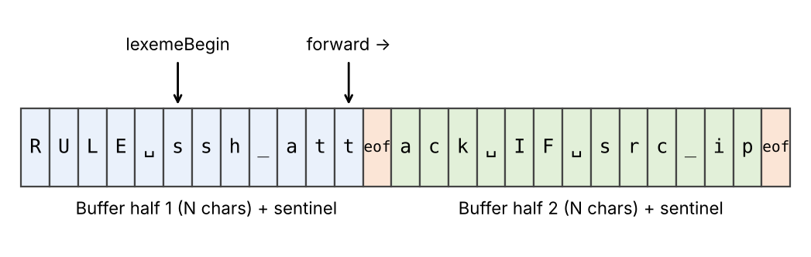
Fig. 6 Buffer pair with sentinels: lexemeBegin and forward pointers while scanning ssh_attack.
switch (*forward++) {
case eof:
if (forward is at end of first half) { reload second half; forward = beginning of second half; }
else if (forward is at end of second half) { reload first half; forward = beginning of first half; }
else /* eof inside a buffer */ terminate lexical analysis; break;
/* cases for the other characters */
}

flex implements the same idea: it reads 16 KB blocks into a buffer and places two end-of-buffer NUL bytes after the data as the sentinel, so the main DFA loop does not test for buffer end on every character.

5.6 Lexical errors in the faulty lines
Faulty line | Lexical error | Why it is an error | Recovery action
src_ip == 10.0.300.5 | Malformed IP address – octet 300 | Octets must be 0–255. The text 10.0.300.5 matches the shape of an IP address but not its range, so no IP lexeme can be formed. | Report “malformed IP address ‘10.0.300.5’” with line (and column); discard the whole malformed lexeme (panic mode – skip to the next delimiter) and continue; the rule is marked invalid so it is not deployed.
ALERT "Login failed ; | Unterminated string | The opening " has no closing " before the end of the line; the ; is swallowed inside the unfinished string. | Report “unterminated string”; skip to the end of the line (strings cannot span lines) and resume scanning at the next line, so one missing quote does not hide the rest of the file.
port == 22 @ attempts > 5 | Illegal character @ | @ is not in the ThreatRule alphabet; it starts no token. | Report “illegal character ‘@’”; delete the character (panic-mode deletion) and continue; the other tokens port == 22 and attempts > 5 are still produced. (The parser will separately report the missing AND.)

Observed output of the compiled scanner v2 on these three faulty lines (line:column in v2; v1 reports the line only):
line 1:11: lexical error: malformed IP address / number '10.0.300.5'
line 2:7: lexical error: unterminated string '"Login failed ;'
line 3:12: lexical error: illegal symbol(s) '@'

Evidence expected (as per the assignment): Clear role of the lexical analyzer (5.1–5.5, Figs. 5–6) and correct identification and recovery of the three faulty lines (5.6).

Task 6 – Specification of Tokens (5 marks)

6.1 Strings, languages and operations on languages
- An alphabet Σ is a finite set of symbols: for ThreatRule, the printable ASCII characters. A string over Σ is a finite sequence of symbols; |s| is its length and ε is the empty string. A prefix of ALERT is ALE; a suffix is ERT; a substring is LER.
- A language is any set of strings over Σ. Example: L(keyword) = {RULE, IF, AND, OR, THEN, ALERT, BLOCK}; L(digit) = {0,…,9}.
- Union L ∪ M = {s | s ∈ L or s ∈ M}; concatenation LM = {st | s ∈ L, t ∈ M}; Kleene closure L\* = ⋃ Lⁱ (i ≥ 0, strings made of zero or more strings of L); positive closure L⁺ = ⋃ Lⁱ (i ≥ 1).
- With L = letters ∪ {\_} and D = digits: L(L ∪ D)\* is the language of identifiers; D⁺ is the language of integers; (D⁺.)³D⁺ is the (shape of the) language of IP addresses.
Regular expressions describe these languages: ε; a symbol *a*; and for regular expressions r, s: (r)|(s), (r)(s), (r)\*, plus the shorthands r⁺ = rr\*, r? = r|ε and character classes [a-z]. The rules of the form *d → r* below are regular definitions; each name may only use names defined before it.

6.2 Token table
Token name | Pattern (regular definition) | Sample lexeme | Attribute value
RULE, IF, AND, OR, THEN, ALERT, BLOCK | keyword | RULE | — (token name identifies it)
ID | id | ssh_attack | index of the lexeme in the symbol table
INTEGER | integer | 5 | its integer value
IP | ipaddr | 10.0.0.5 | 32-bit value 0x0A000005
PORT | port (integer in 0–65535 after port relop) | 22 | its value 22
STRING | string | "SSH brute force" | pointer to the text
RELOP | relop | == >= | EQ, NE, LT, LE, GT, GE
SEMI | ; | ; | —
(none: skipped) | comment, ws | // note | discarded

*Table 6.1 – ThreatRule token table.*

6.3 Regular definitions
letter -> [A-Za-z_]
digit -> [0-9]
id -> letter ( letter | digit )*
keyword -> RULE | IF | AND | OR | THEN | ALERT | BLOCK
integer -> digit+
octet -> 25[0-5] | 2[0-4]digit | 1 digit digit | [1-9]? digit (0 .. 255)
ipaddr -> octet . octet . octet . octet
port -> 0 | [1-9] digit{0,3} | [1-5] digit{4} | 6[0-4] digit{3}
| 65[0-4] digit{2} | 655[0-2] digit | 6553[0-5] (0 .. 65535)
string -> " [^"\n]* "
relop -> == | != | < | <= | > | >=
comment -> // [^\n]*
ws -> ( blank | tab | CR | newline )+
semi -> ;

Port versus integer. port and integer match exactly the same text, so a pure regular expression cannot choose between them. The scanner decides from the previous tokens (it recognises the sequence ID(port) RELOP and then labels the following number as PORT and checks that its value is ≤ 65535, otherwise it reports a “port out of range” lexical error – the boundary case 65535 is accepted, 65536 rejected, Table 9.1 cases 4–5). Everywhere else the number is an INTEGER such as the 5 in attempts > 5.
IP versus malformed number. An additional rule digit+ ( . digit+ )+ (a dotted number that is not a valid ipaddr) is defined only to produce a precise error for text such as 10.0.300.5, 256.1.1.1 or 1.2.3.

6.4 How keywords are separated from identifiers
Keywords have the same shape as identifiers, so the pattern id also matches RULE. They are separated by two LEX rules of conflict resolution: (1) longest match – RULES or IFF is longer than the keyword RULE / IF, so the identifier rule wins and no token is wrongly split; (2) first rule wins on a tie – for the exact lexeme RULE both the keyword rule and the id rule match 4 characters, and the keyword rules are written *before* the identifier rule. Keywords are case-sensitive: if is an identifier, IF is a keyword (Table 9.1 case 9). The alternative used by hand-written scanners – install the keywords in the symbol table in advance and look every identifier up – gives the same result.
Evidence expected (as per the assignment): Complete regular definitions for all ThreatRule tokens (6.3), the token table (Table 6.1), the language operations (6.1) and the keyword/identifier separation (6.4).

Task 7 – Recognition of Tokens (4 marks)
Each token pattern is converted to a transition diagram. Circles are states; arrows are labelled with the input characters; the arrow from the dot marks the start state; double circles are accepting states; an asterisk * on an accepting state means the last character read was a lookahead character that does not belong to the lexeme, so the input pointer is retracted by one (forward--).

7.1 Relational operators
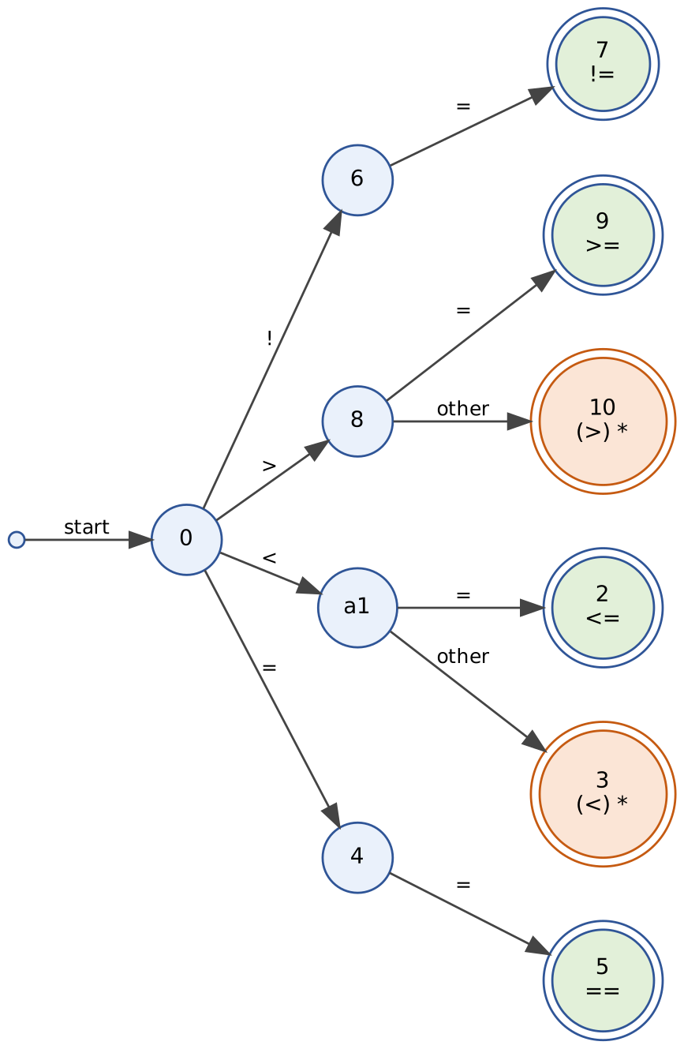
Fig. 7 Transition diagram for relational operators (states 3 and 10 retract).

7.2 Identifiers and keywords
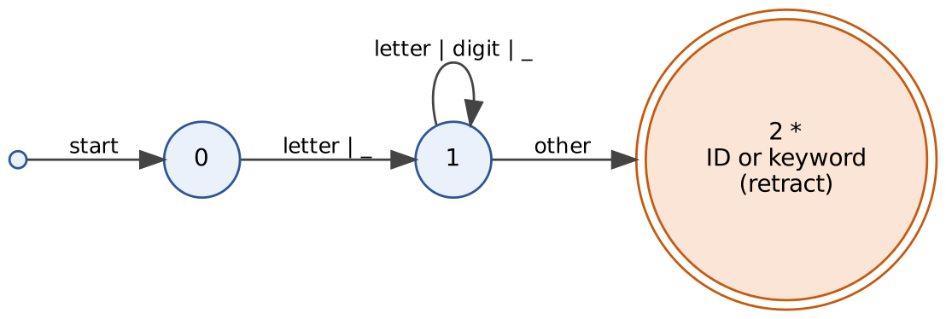
Fig. 8 Transition diagram for identifiers / keywords. After accepting in state 2 the lexeme is looked up in the keyword table; if present the keyword token is returned, otherwise ID and install().

7.3 Integers (and ports)
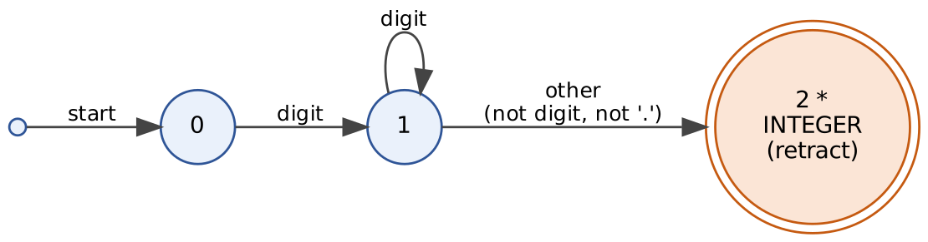
Fig. 9 Transition diagram for integers; the lookahead character is retracted.

7.4 IP addresses
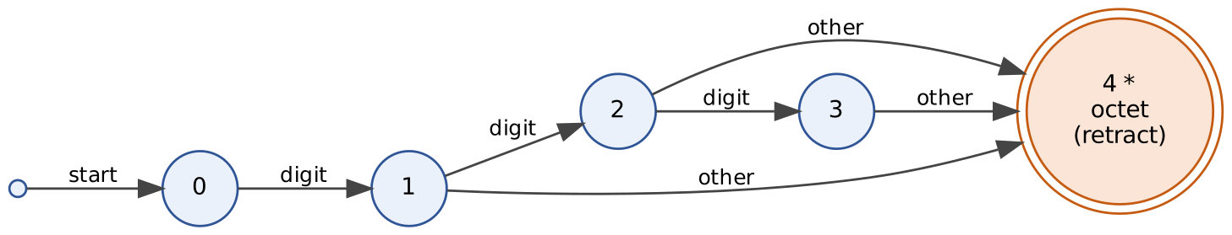
Fig. 10 Sub-diagram “octet”: one to three digits; the first non-digit is retracted. The numeric value must be ≤ 255.
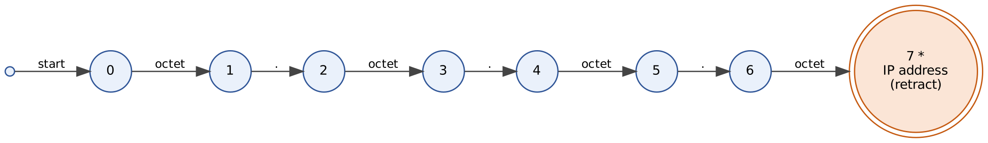
Fig. 11 Transition diagram for IP addresses built from four octets and three dots. State 7 accepts and retracts; if any octet is > 255 or a part is missing (for example 1.2.3), the scanner reports a malformed-IP error instead.

7.5 Strings and comments
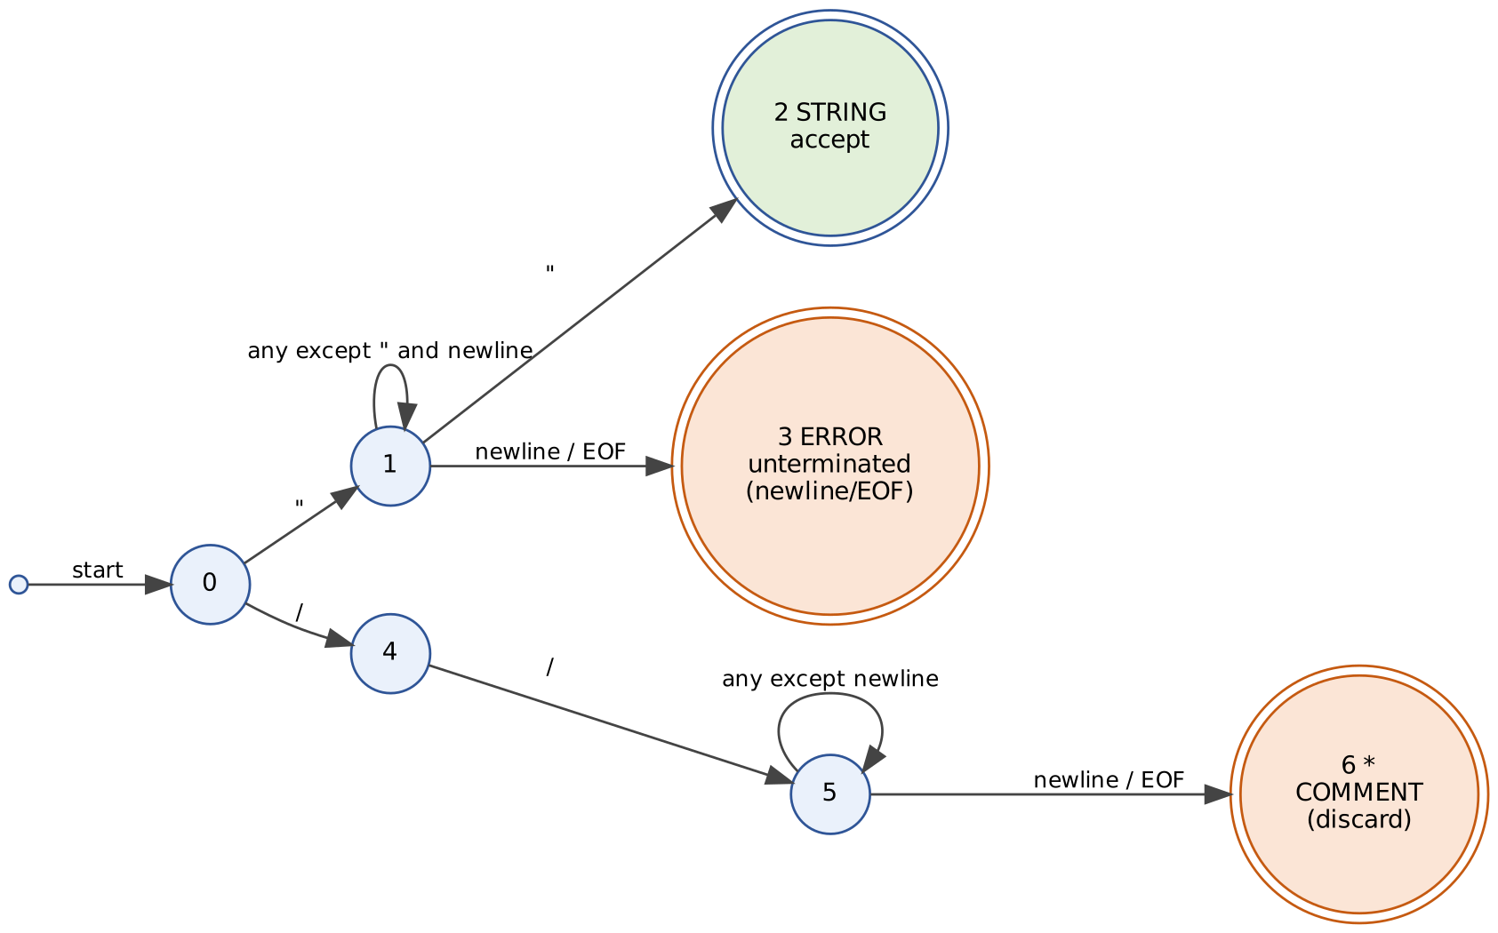
Fig. 12 Transition diagrams for strings (state 2 accepts, state 3 = unterminated-string error) and // comments.

7.6 Start states, accepting states, retraction and lookahead
- Start state: state 0 in each diagram; the scanner reads the first character of the lexeme there.
- Accepting states: 2, 5, 7, 9 in Fig. 7 (no retraction); 3 and 10 in Fig. 7 (retract); 2 in Figs. 8–9; 7 in Fig. 11; 2 in the string diagram (Fig. 12).
- Retraction: a token whose end can only be recognised by reading one character too far – identifiers, integers, IP addresses, <, > – retracts the lookahead character so it is scanned again as the start of the next token. Operators ==, <=, >=, != and the string need no retraction because their last character is part of the lexeme.
- Lookahead for < versus <=: after reading < the scanner is in state 1 and cannot yet decide. It reads the next character: = leads to the accepting state 2 (token <=, no retraction); any other character leads to state 3, which returns < and retracts. This is exactly the longest-match rule: the scanner always prefers the longer operator. The same holds for > / >=; = alone and ! alone are illegal (no transition out of state 4 / 6 except =).

7.7 Hand traces on lexemes of the sample rule

Trace 1 – the lexeme > in attempts > 5 (relational operator, lookahead and retraction)
Step | State | Character read | Action | Next state
1 | 0 (start) | > | take transition > | 8
2 | 8 | (blank) | not = → “other”; blank is lookahead | 10 (accepting *)
3 | 10 | — | retract: forward-- (blank is re-read later); return ⟨RELOP, GT⟩ | —

Trace 2 – the lexeme 10.0.0.5 in src_ip == 10.0.0.5 (IP address; Fig. 10 octet diagram inside Fig. 11)
Step | IP-diagram state | Input read | Action | Next state
1 | 0 | 1 0 then . | octet sub-diagram: 0 →(digit)→ 1 →(digit)→ 2 →(. = other)→ accept, . retracted; octet = 10 ≤ 255 | 1
2 | 1 | . | dot expected and found | 2
3 | 2 | 0 then . | octet sub-diagram: digit, then other (retract); octet = 0 | 3
4 | 3 | . | dot | 4
5 | 4 | 0 then . | octet = 0 | 5
6 | 5 | . | dot | 6
7 | 6 | 5 then blank | octet sub-diagram: digit, then blank = other → retract; octet = 5 | 7 (accepting *)
8 | 7 | — | all four octets ≤ 255 → return ⟨IP, 0x0A000005⟩; the blank is scanned again as white space | —

Trace 3 – the lexeme ssh_attack and the keyword IF (identifier/keyword diagram)
Step | State | Character read | Action | Next state
1 | 0 | s | letter | 1
2 | 1 | s,h,_,a,t,t,a,c,k | letters / digits / _ – loop on state 1 | 1
3 | 1 | (blank) | other → accept, retract | 2 (accepting *)
4 | 2 | — | look up ssh_attack in the keyword table: not found → install() into the symbol table → ⟨ID, index⟩ | —
5 | — | I,F, | same path; lookup IF finds a keyword → return ⟨IF⟩ (no install) | —

Evidence expected (as per the assignment): Transition diagrams (Figs. 7–12) with start/accepting states, retraction and lookahead (7.6) and three hand traces on lexemes of the sample rule (7.7).

Task 8 – Write the LEX Specification (5 marks)
The complete, commented LEX program for the original design is in Appendix A (threatrule.l, 145 lines); the modified program of Task 12 is in Appendix B. The key parts are explained here.

8.1 Structure of a LEX program
%{ C declarations: #includes, token codes, YYSTYPE yylval, symbol table, helper functions %}
%option noyywrap yylineno <- LEX options
letter [A-Za-z_] digit [0-9] <- regular definitions (named patterns)
%%
pattern { C action } <- TRANSLATION RULES
...
%%
auxiliary C functions: tname(), main() driver, timing code <- AUXILIARY FUNCTIONS

8.2 Key rules (extract from Appendix A)
"RULE" { return emit(RULE); } /* keywords BEFORE id */
{id} { yylval.sym = install_id(yytext, yyleng); return emit(ID); }
{ipaddr} { yylval.ip = ip2int(yytext); return emit(IP); } /* before {digit}+ */
{digit}+ { yylval.ival = atoi(yytext); return emit(INTEGER); }
{digit}+(\.{digit}+)+ { LEXERR("malformed IP address / number"); }
\"[^"\n]*\" { return emit(STRING); }
\"[^"\n]* { LEXERR("unterminated string"); }
"==" { yylval.ival = EQ; return emit(RELOP); } /* ... != <= >= < > ... */
"//"[^\n]* { /* comment: discarded */ }
{ws} { /* white space: discarded */ }
\n { /* yylineno++ done by LEX */ }
. { LEXERR("illegal character"); } /* last rule: catch-all */

8.3 yytext, yyleng, yylval and yylineno
- yytext – the lexeme matched by the current rule (a C string); yyleng – its length. Used to copy identifiers into the symbol table (install_id(yytext, yyleng)) and to convert numbers (atoi(yytext)).
- yylval – the attribute value passed to the parser with the token. Here a union: sym (symbol-table index for ID), ival (integer / port / relop code), ip (32-bit address). Every rule that returns a token sets yylval first; the ID rule sets yylval.sym as required (Appendix A, rule {id}).
- yylineno – current input line, maintained by LEX when %option yylineno is given; used in every error message and in the verbose token listing.

8.4 Installing identifiers in the symbol table
The action of the {id} rule calls install_id(yytext, yyleng), which hashes the lexeme (a multiplicative hash, table of 2²⁰ slots with linear probing). If the lexeme is already present its index is returned; otherwise it is stored (copied) and a new index is created. Therefore the 100,000-rule file, which has 100,003 distinct identifiers, creates exactly that many entries (Table 10.1 column “symbols”), while repeated names (src_ip, port, …) share one entry. Keywords never reach this function because they are matched by earlier rules.

8.5 Longest match and first-rule priority
When several patterns match at the current position LEX applies two rules: (1) the pattern giving the longest lexeme wins; (2) if two patterns match the same length, the one listed first wins. Consequences used in this specification:
Input | Competing rules | Winner and reason
RULE | keyword "RULE" and {id} (both length 4) | keyword – listed first
RULES | keyword (4) vs {id} (5) | {id} – longer
<= | "<" (1) vs "<=" (2) | <= – longer
10.0.0.5 | {ipaddr}, {digit}+ (matches 10), malformed-number rule (8) | {ipaddr} – listed before the malformed rule, same length 8; both beat {digit}+
10.0.300.5 | {ipaddr} cannot match the full text; malformed rule matches 10 chars | malformed-number rule – longest → error is reported
"abc (no closing quote) | string cannot match; unterminated-string rule | unterminated-string rule → error

8.6 How LEX produces lex.yy.c
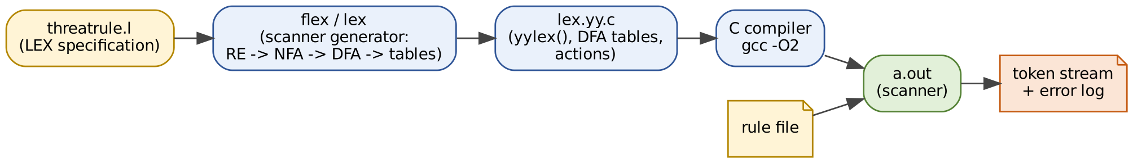
Fig. 13 From LEX specification to a running scanner.
The LEX/flex program reads threatrule.l; the regular expressions are converted into an NFA (Thompson construction), the NFA states of all rules are combined, the combined NFA is converted into a DFA (subset construction) and minimised; each accepting DFA state remembers the rule it belongs to (the earliest rule if several accept). The DFA is written as transition tables into lex.yy.c, together with the driver function yylex() – which runs the DFA, records the last accepting state and position to implement longest match, backs up to it, sets yytext/yyleng, and executes the rule’s action – and the C text of the actions and the user sections. The file is compiled with an ordinary C compiler. Build commands used here:
flex -o lex.yy.c threatrule.l # LEX specification -> scanner source (lex.yy.c)
gcc -O2 -o tr1 lex.yy.c # C compiler -> executable scanner
./tr1 -v rules.tr # print token stream; errors go to stderr

Evidence expected (as per the assignment): Complete commented LEX program (Appendix A), explanation of yytext/yyleng/yylval/yylineno, symbol-table installation, conflict resolution and lex.yy.c generation.

Task 9 – Implement and Test the Lexical Analyzer (4 marks)

9.1 Method (reproducible procedure)
The scanner was built from threatrule.l with flex 2.6.4 and compiled with gcc -O2. The binary that is measured is the flex-generated scanner – the numbers in this report are not from a reference model. Procedure (all commands and scripts are in Appendix C):
- Build: flex -o lex.yy.c threatrule.l && gcc -O2 -o tr1 lex.yy.c.
- Unit tests: python3 unit.py runs 13 small inputs through the scanner (-v prints the token stream; errors go to stderr) and compares the produced token-name sequence and error count with the expected values derived from Tasks 6–7 (Table 9.1).
- Scale tests: gen.py N file.tr creates a deterministic rule file of N rules (seeded); sizes 100, 1,000, 10,000 and 100,000. Rules mix AND/OR conditions, ALERT/BLOCK actions, IP/port/integer tests, comment lines every 25 rules, blank lines, and rules split over two lines. --errors 50 corrupts every 50th rule with a known fault (cycling through malformed IP, unterminated string, malformed number, stray @, port out of range), so the number of injected faults is known exactly.
- Timing: the scanner times its own scanning loop with clock_gettime; each file is run 11–21 times and the median is reported (bench.py).

9.2 Test results – valid, invalid and boundary cases
# | Test case | Input | Expected tokens | Observed tokens | Result
1 | Sample rule from scenario | RULE ssh_attack IF src_ip == 10.0.0.5 AND port == … | RULE ID IF ID REL IP AND ID REL PORT AND ID REL INTEGER THEN ALERT STRING SEMI | RULE ID IF ID REL IP AND ID REL PORT AND ID REL INTEGER THEN ALERT STRING SEMI | PASS
2 | Boundary IP 0.0.0.0 | src_ip == 0.0.0.0 | ID REL IP | ID REL IP | PASS
3 | Boundary IP 255.255.255.255 | dst_ip != 255.255.255.255 | ID REL IP | ID REL IP | PASS
4 | Boundary port 65535 (valid) | port == 65535 | ID REL PORT | ID REL PORT | PASS
5 | Port 65536 (out of range) | port == 65536 | ID REL (+1 err) | ID REL (+1 err) | PASS
6 | Invalid IP 256.1.1.1 and 10.0.300.5 | src_ip == 256.1.1.1 ⏎ src_ip == 10.0.300.5 | ID REL ID REL (+2 err) | ID REL ID REL (+2 err) | PASS
7 | Unterminated string | ALERT "Login failed ; ⏎ BLOCK "ok" ; | ALERT BLOCK STRING SEMI (+1 err) | ALERT BLOCK STRING SEMI (+1 err) | PASS
8 | Stray character @ | port == 22 @ attempts > 5 | ID REL PORT ID REL INTEGER (+1 err) | ID REL PORT ID REL INTEGER (+1 err) | PASS
9 | Keywords vs identifiers (RULES, IFF, if, ALERT) | RULES IFF if ALERT | ID ID ID ALERT | ID ID ID ALERT | PASS
10 | All relational operators | < <= > >= == != | REL REL REL REL REL REL | REL REL REL REL REL REL | PASS
11 | Comment, white space and line numbers | // full-line comment ⏎ RULE r1 // trailing ⏎ … | RULE ID IF | RULE ID IF | PASS
12 | Empty file / no trailing newline | (empty) |  |  | PASS
13 | Single '=' and '!' (illegal) | a = b ! c | ID ID ID (+2 err) | ID ID ID (+2 err) | PASS

*Table 9.1 – Unit tests (observed = output of the compiled flex scanner). All 13 cases pass for both scanners; “REL” = RELOP, “err” = lexical errors reported.*
Boundary cases: 0.0.0.0 and 255.255.255.255 are accepted as IP (cases 2–3); port 65535 accepted, 65536 rejected as out-of-range (cases 4–5); 256.1.1.1 and 10.0.300.5 rejected (case 6). Error recovery evidence: the observed run on the sample faulty file (3 errors on 3 different lines) continues after every error – see 5.6 and the error-injected files below.

9.3 Scanner output on test files
$ ./tr1 clean_100.tr
SUMMARY last_line=121 rules=100 tokens=1452 errors=0 symbols=103 time_ms=0.17

$ ./tr1 err_1000.tr 2>errors.log # 1 faulty rule in 50
SUMMARY last_line=1208 rules=1000 tokens=13892 errors=20 symbols=1004 time_ms=1.71

$ head -3 errors.log
line 60: lexical error: unterminated string '"Login failed ;'
line 120: lexical error: malformed IP address / number '1.2.3'
line 180: lexical error: illegal character '@'

For every error-injected file the number of errors reported equals the number of injected faults exactly (2, 20, 200 and 2,000 for 100 / 1,000 / 10,000 / 100,000 rules, Table 10.2) – no fault was missed and no valid rule was rejected – and scanning always continued to the end of the file. The scanner matches the specification of Tasks 6–8: the token names, attribute values and priorities in the observed output are those of Table 6.1 and Section 8.5.
Evidence expected (as per the assignment): A working compiled LEX scanner (Appendix A), valid/invalid/boundary tests (Table 9.1), four file sizes, and a reproducible procedure (9.1, Appendix C).

Task 10 – Record Scanner Performance (3 marks)

10.1 Systematically collected data
Rules | Lines | Size (MB) | Tokens | Symbols | Lexical errors | Scan time (ms) | MB/s | µs per token
100 | 120 | 0.01 | 1,452 | 103 | 0 | 0.172 | 52 | 0.118
1,000 | 1,207 | 0.09 | 13,812 | 1,003 | 0 | 1.250 | 71 | 0.091
10,000 | 12,078 | 0.91 | 139,820 | 10,003 | 0 | 12.305 | 74 | 0.088
100,000 | 120,785 | 9.30 | 1,400,640 | 100,003 | 0 | 129.132 | 72 | 0.092

*Table 10.1 – Original scanner (v1) on valid rule files; median of 11–21 runs on this machine.*
Rules | Lines | Faults injected (1 in 50) | Lexical errors detected | Tokens | Scan time (ms)
100 | 120 | 2 | 2 | 1,457 | 0.176
1,000 | 1,207 | 20 | 20 | 13,892 | 1.711
10,000 | 12,078 | 200 | 200 | 140,620 | 12.824
100,000 | 120,785 | 2000 | 2000 | 1,407,624 | 133.170

*Table 10.2 – Original scanner on the same files with injected faults.*

10.2 Graphs
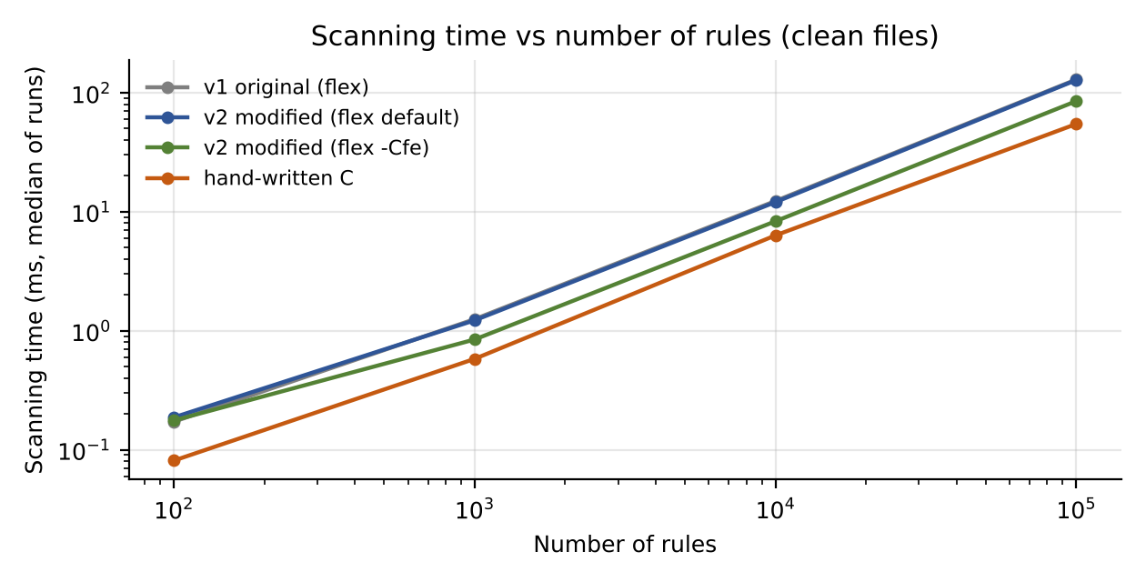
Fig. 14 Scanning time against number of rules (log–log). Time grows linearly: ×10 rules ≈ ×10 time.
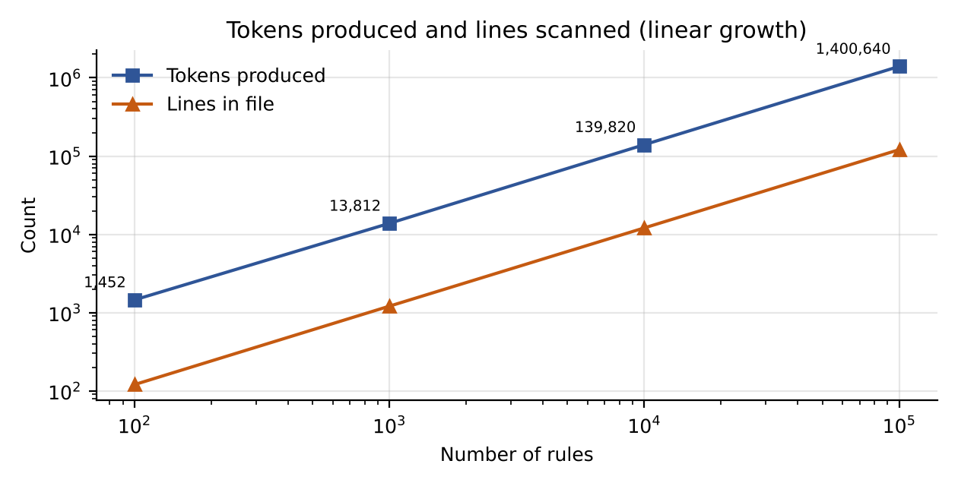
Fig. 15 Number of tokens produced and lines scanned against number of rules.
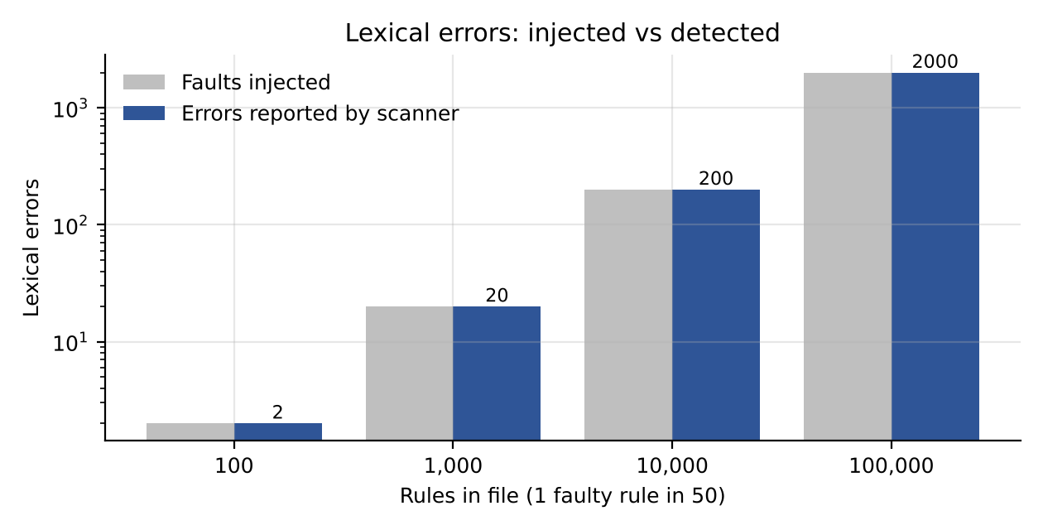
Fig. 16 Lexical errors injected versus detected (v2 shown; v1 detects the same numbers on these files).
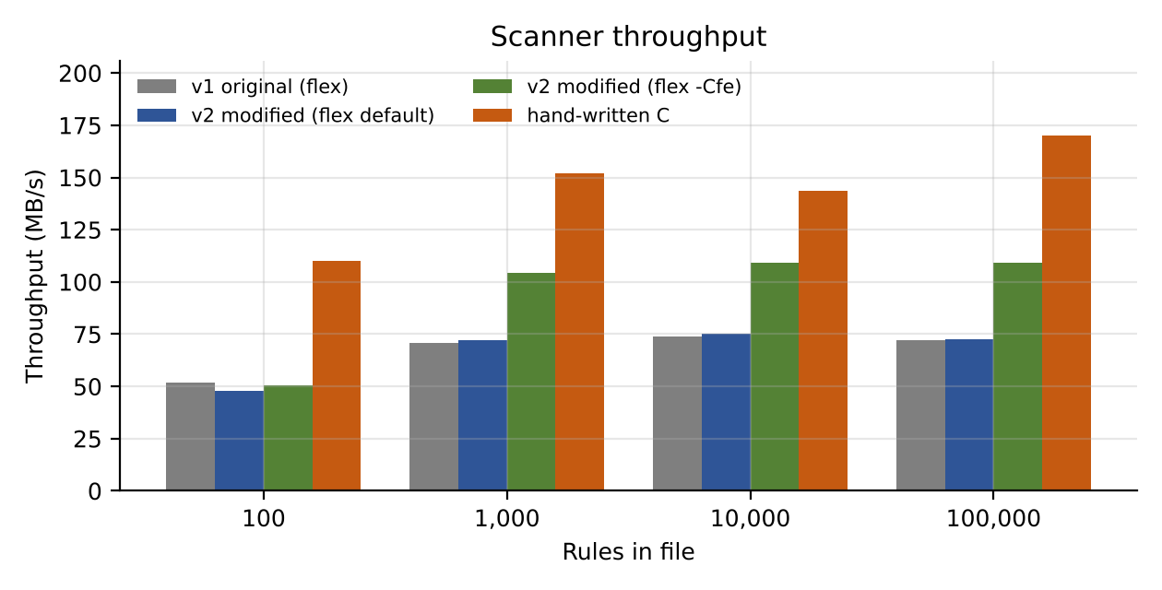
Fig. 17 Throughput in MB/s for the original scanner, the modified scanner, the modified scanner built with flex -Cfe, and a hand-written scanner.
Observations. Tokens grow linearly with rules (≈14 per rule). Scanning time is linear: ×10 in rules gives ×7.3, ×9.8 and ×10.5 in time; time per token stays at ≈0.09 µs, i.e. the DFA works in O(n) regardless of the number of rules, because a rule is just more input and the number of patterns (not rules) determines the table size. Errors detected = errors injected at every size. The symbol table holds one entry per distinct identifier (≈ number of rules + 3 field names).
Evidence expected (as per the assignment): Rules/lines, tokens, scanning time and errors for each file size (Tables 10.1–10.2), presented as four graphs (Figs. 14–17).

Task 11 – Recommend and Defend the Final Design (2 marks)
Recommendation: the central SOC should use the LEX (flex) generated scanner specified in Appendix A – a single DFA built from the regular definitions of Task 6 – driven by the parser on demand, with identifiers installed in a hash-based symbol table and every error reported with its line (and later column), then built with flex -Cfe for production speed.
- Suitability. The token set is regular, so a DFA is the exactly right recogniser; the specification is short, readable and is itself the language documentation; longest-match/first-rule priority gives the required keyword/identifier and </<= behaviour automatically; all 13 functional tests, including the boundary cases 0.0.0.0, 255.255.255.255 and port 65535, pass (Table 9.1).
- Observed performance. The 100,000-rule file (120,785 lines, 9.3 MB, 1,400,640 tokens) is scanned in 129 ms with default flex (72 MB/s) and in 85 ms with -Cfe; time is linear in input size (Fig. 14); the error-injected files are scanned at the same speed and every injected fault is reported (Table 10.2).
- Practicality as the rule count grows. Cost is proportional to the number of characters, so 1,000,000 rules (≈90 MB) would take about 1.3 s with the default tables. The scanner needs no more memory than the input buffer plus the symbol table (≈100,000 identifiers for 100,000 rules; a 2²⁰-slot table is sufficient to about 700,000 distinct names and can be enlarged). Lexing is therefore never the bottleneck of the compile; the parser, semantic checks and optimiser dominate.
- Limitations. (i) The context rule that turns the integer after port == into a PORT is a small hand-coded state machine, not pure regular-expression matching. (ii) v1 handles only the original tokens – hashes, CVE numbers and URLs are not recognised and // in a URL is treated as a comment (Task 12). (iii) Error recovery is character/lexeme-level and message-per-error; no column (added in v2). (iv) Identifiers/keywords are ASCII-only and case-sensitive. (v) The scanner assumes the whole file is valid text; very long lines are handled but a single unterminated string is only closed at the end of its line.
Evidence expected (as per the assignment): A technically justified recommendation – suitability, measured performance (Figs. 14–17), limitations and practicality – supported by own testing.

Task 12 – Re-evaluate and Adapt the Design (8 marks) [Day-4 Design Challenge]
Changed requirement: the central SOC now receives live threat feeds from partner organisations. The feeds add file hashes, CVE numbers (for example CVE-2024-3400) and URLs, and the scanner must report every error with its line number and continue instead of stopping. Decision: MODIFY the original design (retain the LEX architecture, add three tokens, upgrade the error handling).

12A. Impact Analysis (2 marks)

What has changed
- New token types – hash (MD5 = 32, SHA-1 = 40, SHA-256 = 64 hexadecimal digits), CVE number CVE-YYYY-NNNN… (4-digit year, 4–7 digit sequence) and URL http(s)://….
- New data source – feeds are produced by external organisations, so malformed or malicious input is expected rather than exceptional, and the volume is continuous (a streaming input of unknown length) rather than a fixed rule file.
- Error policy – every error must be reported with its position and scanning must continue (“report all, never stop”).

Which original token specifications are affected
Original specification | Effect of the new tokens
id → letter (letter|digit)* | A hash starting with a letter (e.g. d41d8cd9…) matches id in full; CVE matches id as the first three letters of a CVE number; http / https match id.
integer → digit+ | A hash starting with digits (e.g. 9e107d9d…) matches integer for its first digits; the year and the sequence of a CVE (2024, 3400) are matched as separate integers.
comment → // [^\n]* | The // in http://… starts a comment: the rest of the line – including THEN BLOCK "…" ; – would be thrown away silently.
Catch-all rule . | The characters - (in CVE) and : (in URL) belong to no original token and would each be an illegal-character error.
Symbol table (install) | Hash literals recognised as identifiers would be installed as “names” and flood the symbol table.

Why the new tokens may conflict with existing patterns
LEX decides by longest match and then first rule, so each new token must be positioned correctly: (1) Hash vs identifier vs integer – a 32-hex-digit lexeme matches hash, id (if it starts with a letter) and integer/id (if it starts with a digit) with the *same length*; the hash rule must be listed before both, and a hash that starts with digits must not be split. (2) CVE vs identifier – CVE-2024-3400 is longer than the identifier CVE, so longest match selects the CVE rule automatically, but a *malformed* CVE needs its own rule or it breaks into ID/INT/illegal-character tokens. (3) URL vs identifier and comment – the URL pattern must start at http/https so that the scheme http is not an ID and the // is not a comment; it must stop at whitespace, " or ;. (4) Ambiguity by design – an ordinary identifier that happens to consist of exactly 32/40/64 hex letters/digits (for example a 32-character name using only a–f) would be taken as a hash; it is the unavoidable price of using the length as the only context (the generated test data and ThreatRule naming convention do not contain such names).

Why continuous error reporting is now important
- Feeds are produced by third parties and will contain faults; stopping at the first error would reject (or hide the remaining errors of) a file of tens of thousands of rules and delay detection of live attacks.
- The central SOC needs a complete error list in one run (one line:column per fault) so the partner can fix everything at once.
- A scanner that stops, or that silently mis-tokenises (as v1 does with hashes), either blocks protection or lets wrong rules into the engine. Reporting every error, recovering locally and returning a count at the end allows the valid rules of a feed to be used while the faulty ones are quarantined.

12B. Evaluation of the Original Design (2 marks)

Can the original LEX program recognise the new tokens?
No. The test is a clean feed file of 5,000 rules (generator option --feed) that contains 1,667 hash literals, 834 CVE numbers and 833 URLs = 3,334 new-token literals, no faults at all. The original scanner (v1) recognised 0 of 3,334 as the correct token. Observed output on three sample feed rules (v1):
RULE f1 IF file_hash == 9e107d9d372bb6826bd81d3542a419d6 THEN BLOCK "md5" ;
-> ... RELOP(==) INTEGER(9) ID(e107d9d372bb6826bd81d3542a419d6) THEN ... (hash split, NO error)
RULE f2 IF cve == CVE-2024-3400 THEN ALERT "PAN-OS" ;
-> ... RELOP(==) ID(CVE) [error: illegal character '-'] INTEGER(2024)
[error: illegal character '-'] INTEGER(3400) THEN ...
RULE f3 IF url == http://evil.example.com/a.php?id=1 THEN BLOCK "phish" ;
-> ... RELOP(==) ID(http) [error: illegal character ':']
COMMENT(//evil.example.com/a.php?id=1 THEN BLOCK "phish" ;) <- rest of rule lost

Measure on the 5,000-rule clean feed (v1) | Result | Correct value
Hash literals recognised as HASH | 0 of 1,667 – letter-initial hashes become one ID, digit-initial hashes become INTEGER + ID, silently (no error) | 1,667
CVE literals recognised | 0 of 834 – ID + two illegal-character errors + two INTEGERs each | 834
URL literals recognised | 0 of 833 – ID + illegal : + the rest of the line swallowed as a comment | 833
Lexical errors reported | 2,501 spurious errors (834 × 2 for CVE + 833 for URLs) – on a file with no real fault | 0
Symbol-table entries | 6,676 (hash strings and the names CVE, http, https polluted the table) | 5,006
Rules whose tail was lost | 833 (URL rules: THEN BLOCK "…" ; swallowed by the // comment) | 0

*Table 12.1 – Evaluation of the original scanner on partner-feed data.*

Is the original error handling sufficient?
No. (i) It reports line numbers but no column, so a fault inside a long rule cannot be located. (ii) Recovery is per character: one malformed token produces a cascade of messages (the 2,501 messages above come from only 1,667 literals), burying real faults. (iii) It has no error classes and gives no summary by type. (iv) The worst weakness is not an error message but a silent failure: hashes and URL-rules are mis-tokenised without any error, which is more dangerous for a security tool. (v) In v1 the // comment pattern is the only construct that can swallow the remainder of a line.

Could another design perform better?
Three alternatives were built and measured (Table 12.2 / Figs. 18–19): (a) the same LEX specification extended (v2); (b) v2 generated with flex -Cfe (full uncompressed tables); (c) a hand-written C scanner with identical behaviour on the benchmark data (handscan.c, 77 dense lines). The hand-written scanner is the fastest (about 2.3× the speed of default v2 and 1.6× the speed of -Cfe on the 100,000-rule feed) but it is harder to extend and to prove correct, and (as the reference counts show) must replicate longest-match logic by hand; it was verified only to give identical token, error and symbol counts on all benchmark files, not on arbitrary malformed text. A token-level redesign (for example a separate pre-scan for hashes/URLs) would add a second pass over the data without giving a better result than one DFA.

12C. Adaptation or Redesign (2 marks)

Decision: MODIFY
The architecture (one flex DFA, symbol table, on-demand tokens) is retained because the new tokens are still regular and fit the same mechanism; a redesign is not necessary. The scanner is modified in three ways: new regular definitions and rules, a new error-recovery design, and better diagnostics.

New regular definitions
hex -> [0-9A-Fa-f]
hash -> hex{32} | hex{40} | hex{64} /* MD5 | SHA-1 | SHA-256 */
cve -> CVE - digit{4} - digit{4,7}
urlch -> [A-Za-z0-9._~:/?#@!$&'()*+,=%-]
url -> ( http | https ) :// urlch+

New LEX rules (extract from Appendix B – placement is essential)
{hash} { yylval.str = yytext; return emit(HASH); } /* BEFORE {id} and {digit}+ : same length -> first rule wins */
{cve} { yylval.str = yytext; return emit(CVE); } /* longer than the identifier "CVE" */
CVE-[^ \t\r\n;]* { LEXERR(4, "malformed CVE identifier"); } /* after {cve}: tie -> valid one wins */
{url} { yylval.str = yytext; return emit(URL); } /* starts at "http" -> "//" can never start a comment */
{id} { yylval.sym = install_id(yytext, yyleng); return emit(ID); }

Changes to error recovery
- Report every error, never stop: each error is printed to the error log with line:column and an error class (illegal-character, malformed-number/IP, unterminated-string, port-range, malformed-CVE, symbol-run); the scanner always resumes; the final summary prints the total and a per-class count; the exit code is non-zero if any error occurred so a pipeline can quarantine the feed.
- Panic-mode resynchronisation by run: a new rule [^A-Za-z0-9_ \t\r\n";=!<>]+ consumes a whole run of illegal symbols as one error (@@@ → one message instead of three); malformed CVE numbers consume up to the next delimiter; unterminated strings skip to end of line; malformed numbers/IPs are discarded as one lexeme.
- Column tracking: YY_USER_ACTION updates a column counter on every match; the newline rule resets it.
- Unchanged: all original rules, token codes and the symbol table; only HASH, CVE and URL are added to the token enumeration and to the value non-terminal of the grammar.

What has changed in the design
Component | Original (v1) | Modified (v2)
Token set | keywords, ID, IP, PORT, INTEGER, STRING, RELOP, ; | + HASH, CVE, URL
Rule order | keywords, id, ip, integer … | keywords, hash, cve, url, id, ip, integer …
Error position | line | line:column
Error recovery | one message per illegal character | run-based panic mode + per-class recovery; per-class summary
Malformed CVE | ID + illegal characters + integers | one “malformed CVE” error
Build | flex default tables | flex default tables or -Cfe for speed
Specification size | 145 lines | 167 lines (+22)

12D. Evidence-Based Defence (2 marks)

Test results on the new feed data
Feed rules (clean) | v1 tokens | v1 errors (all spurious) | v2 tokens | v2 errors | Symbols v1 / v2
100 | 1,171 | 51 | 1,180 | 0 | 142 / 106
1,000 | 11,915 | 501 | 11,940 | 0 | 1,342 / 1,006
5,000 | 59,766 | 2,501 | 59,876 | 0 | 6,676 / 5,006
10,000 | 119,773 | 5,001 | 120,092 | 0 | 13,342 / 10,006
100,000 | 1,196,514 | 50,001 | 1,199,544 | 0 | 133,342 / 100,006

Feed rules with 1 fault in 20 | Faults injected | v1 errors reported | v2 errors reported | v2 = injected?
100 | 5 | 56 | 5 | yes
1,000 | 50 | 551 | 50 | yes
5,000 | 250 | 2,751 | 250 | yes
10,000 | 500 | 5,501 | 500 | yes
100,000 | 5000 | 55,001 | 5,000 | yes

v2 recognises all 3,334 new-token literals of the 5,000-rule clean feed with 0 errors, and on the faulty feeds it reports exactly the injected number of errors at every size (all with line:column) and always continues to the end of the file. v1 reports thousands of spurious errors and misses the real structure.

Scanning time compared with the original design
Rules | Clean rules: v1 (ms) | Clean rules: v2 (ms) | v2 vs v1 | Feed: v1 (ms) | Feed: v2 (ms) | Feed: v2 -Cfe (ms) | Feed: hand-written (ms)
100 | 0.172 | 0.187 | +8.7% | 0.281 | 0.168 | 0.139 | 0.085
1,000 | 1.250 | 1.223 | -2.2% | 2.274 | 1.170 | 0.794 | 0.555
10,000 | 12.305 | 12.044 | -2.1% | 18.806 | 11.853 | 7.644 | 5.057
100,000 | 129.132 | 127.808 | -1.0% | 150.525 | 122.286 | 77.401 | 49.148

*Table 12.2 – Scanning time (median). On ordinary rules v2 costs about the same as v1, because the extra patterns only enlarge the DFA tables; on feed data v2 is faster than v1 because v1 loses time producing thousands of error messages and installing junk symbols.*
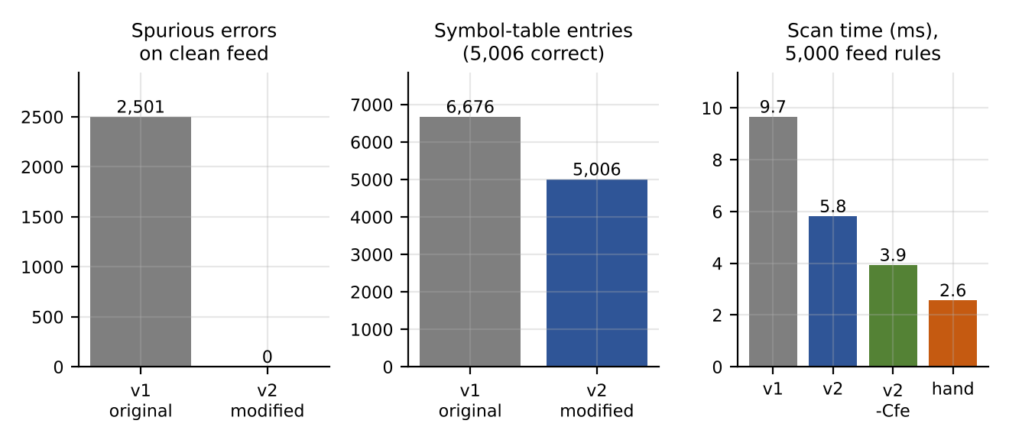
Fig. 18 Evidence on the 5,000-rule clean feed: spurious errors, symbol-table pollution and scan time for v1, v2, v2 -Cfe and the hand-written scanner.
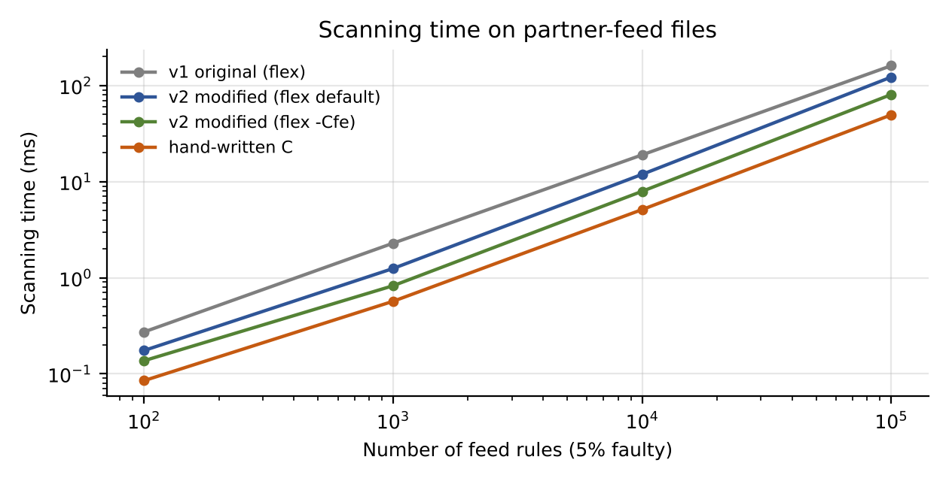
Fig. 19 Scanning time on partner-feed files (5% faulty rules) as the number of rules grows.

Trade-offs
- Speed of the scanner vs maintainability. A hand-written scanner is the fastest (≈49 ms for 100,000 feed rules) but takes more code, is harder to extend and to verify; flex -Cfe reaches ≈77 ms (within about 1.6× of hand-written) at the cost of larger tables (60 KB binary vs 53 KB). Lexing 10 MB in 0.08 s is not a bottleneck, so maintainability wins.
- Hash ambiguity. Defining a hash purely by length (32/40/64 hex digits) means a 32/40/64-character identifier made of only hex letters would be read as a hash; a 33-digit hex string is read as an identifier (not flagged). Reducing the risk would require a prefix such as sha256: in the feed format – to be agreed with the partners.
- URL character set. The URL pattern stops at whitespace, " or ;; legal URLs containing those characters would be truncated (the rest becomes errors, reported with line and column).
- Port classification remains a small context rule, as in v1.
- Recovery granularity. Run-based recovery reports fewer, clearer errors but a run such as @@@ is one error rather than three.

Final decision
MODIFY – keep the LEX-based scanner, extended as in 12C, and build it with flex -Cfe. The decision follows from the evidence: v1 cannot recognise any of 3,334 new-token literals (0 recognised, 2,501 spurious errors, 1,667 silent mis-tokenisations, 833 rules truncated by the // comment conflict, 1,670 junk symbol-table entries); v2 recognises them all, reports exactly the injected faults with line:column and continues; the cost is negligible on ordinary rules (v2 vs v1 about +3% at 100,000 rules) and v2 is faster than v1 on feed data; and the remaining gap to a hand-written scanner (≈1.6× with -Cfe) does not justify giving up the maintainability of a specification that took 22 extra lines to extend. A retain decision is ruled out by the failures above, and a redesign (hand-written or multi-pass scanner) is not justified by the performance numbers.
Evidence expected (as per the assignment): Impact analysis (12A), evaluation of the original design with test evidence (12B, Table 12.1), new regular definitions, LEX rules and error recovery (12C), and an evidence-based final decision (12D, Table 12.2, Figs. 18–19).

Appendix A – threatrule.l (original scanner, v1)
Complete, commented LEX source used in Tasks 8–11. Build: flex -o lex.yy.c threatrule.l && gcc -O2 -o tr1 lex.yy.c.
/* =====================================================================
* threatrule.l -- ORIGINAL lexical analyzer (v1) for ThreatRule
* Tokens: keywords, identifiers, IP, port, integer, string, relational
* operators, ';' and comments. Build: flex threatrule.l
* ===================================================================== */

/* ---------------------- 1. DECLARATIONS SECTION --------------------- */
%{
#include <stdio.h>
#include <stdlib.h>
#include <string.h>
#include <time.h>

/* Token codes (a parser generator such as yacc would normally supply these) */
enum { T_EOF = 0, RULE = 258, IF, AND, OR, THEN, ALERT, BLOCK,
ID, INTEGER, IP, PORT, STRING, RELOP, SEMI };
enum { EQ = 1, NE, LT, LE, GT, GE }; /* attribute values of RELOP */

/* yylval: attribute value that is passed to the parser with every token */
typedef union { int ival; unsigned int ip; int sym; char *str; } YYSTYPE;
YYSTYPE yylval;

/* ---- symbol table: open-addressing hash table of identifier lexemes ---- */
#define SYMSIZE (1 << 20)
static char *symtab[SYMSIZE];
static int nsyms = 0;
static int install_id(const char *s, int n) { /* returns table index */
unsigned h = 5381;
for (int i = 0; i < n; i++) h = h * 33u + (unsigned char)s[i];
h &= SYMSIZE - 1;
while (symtab[h]) {
if (strncmp(symtab[h], s, n) == 0 && symtab[h][n] == '\0') return (int)h;
h = (h + 1) & (SYMSIZE - 1);
}
symtab[h] = strndup(s, n); nsyms++;
return (int)h;
}

static long ntokens = 0, nerrors = 0, nrules = 0;
static int verbose = 0;
static FILE *errlog;
static int pstate = 0; /* 0 idle, 1 saw 'port', 2 saw 'port' RELOP */
static const char *tname(int t);

/* emit(): single exit point for every token; also tracks the context that
turns the integer after port <relop> into a PORT token. */
static int emit(int t) {
if (t == ID && yyleng == 4 && !strcmp(yytext, "port")) pstate = 1;
else if (t == RELOP && pstate == 1) pstate = 2;
else if (t == INTEGER && pstate == 2) {
pstate = 0;
if (yylval.ival > 65535) { /* range error, not a token */
fprintf(errlog, "line %d: lexical error: port out of range '%s'\n", yylineno, yytext);
nerrors++; return -1;
}
t = PORT;
} else pstate = 0;
if (t == RULE) nrules++;
ntokens++;
if (verbose) {
printf("%-5d %-8s %-24s", yylineno, tname(t), yytext);
if (t == ID || t == INTEGER || t == PORT || t == RELOP) printf(" attr=%d", yylval.ival);
else if (t == IP) printf(" attr=0x%08X", yylval.ip);
printf("\n");
}
return t;
}
#define LEXERR(msg) do { fprintf(errlog, "line %d: lexical error: %s '%s'\n", \
yylineno, msg, yytext); nerrors++; pstate = 0; } while (0)
static unsigned ip2int(const char *s) {
unsigned a, b, c, d; sscanf(s, "%u.%u.%u.%u", &a, &b, &c, &d);
return (a << 24) | (b << 16) | (c << 8) | d;
}
%}

%option noyywrap yylineno nounput noinput

/* ---------------------- regular definitions ------------------------- */
digit [0-9]
letter [A-Za-z_]
id {letter}({letter}|{digit})*
octet (25[0-5]|2[0-4][0-9]|1[0-9][0-9]|[1-9]?[0-9])
ipaddr {octet}\.{octet}\.{octet}\.{octet}
ws [ \t\r]+

%%
/* ---------------------- 2. TRANSLATION RULES ---------------------- */
/* Keywords come BEFORE the identifier rule: for an identical lexeme length
LEX picks the earlier rule; for longer text (RULES) the id rule wins. */
"RULE" { return emit(RULE); }
"IF" { return emit(IF); }
"AND" { return emit(AND); }
"OR" { return emit(OR); }
"THEN" { return emit(THEN); }
"ALERT" { return emit(ALERT); }
"BLOCK" { return emit(BLOCK); }

{id} { yylval.sym = install_id(yytext, yyleng); return emit(ID); }

{ipaddr} { yylval.ip = ip2int(yytext); return emit(IP); } /* before {digit}+ */
{digit}+ { yylval.ival = (yyleng > 9) ? 2147483647 : atoi(yytext);
{ int t = emit(INTEGER); if (t < 0) break; return t; } }
{digit}+(\.{digit}+)+ { LEXERR("malformed IP address / number"); }

\"[^"\n]*\" { yylval.str = yytext; return emit(STRING); }
\"[^"\n]* { LEXERR("unterminated string"); }

"==" { yylval.ival = EQ; return emit(RELOP); }
"!=" { yylval.ival = NE; return emit(RELOP); }
"<=" { yylval.ival = LE; return emit(RELOP); }
">=" { yylval.ival = GE; return emit(RELOP); }
"<" { yylval.ival = LT; return emit(RELOP); }
">" { yylval.ival = GT; return emit(RELOP); }
";" { return emit(SEMI); }

"//"[^\n]* { /* comment: discarded, no token returned */ }
{ws} { /* white space: discarded */ }
\n { /* newline: yylineno incremented automatically by LEX */ }

. { LEXERR("illegal character"); } /* catch-all: last rule */
%%
/* ---------------------- 3. AUXILIARY FUNCTIONS -------------------- */
static const char *tname(int t) {
static const char *n[] = {"RULE","IF","AND","OR","THEN","ALERT","BLOCK",
"ID","INTEGER","IP","PORT","STRING","RELOP","SEMI"};
return (t >= RULE && t <= SEMI) ? n[t - RULE] : "?";
}
int main(int argc, char **argv) {
const char *file = NULL;
errlog = stderr; setvbuf(stderr, NULL, _IOFBF, 1 << 16);
for (int i = 1; i < argc; i++) {
if (!strcmp(argv[i], "-v")) verbose = 1; else file = argv[i];
}
yyin = file ? fopen(file, "r") : stdin;
if (!yyin) { perror(file); return 2; }
struct timespec t0, t1;
clock_gettime(CLOCK_MONOTONIC, &t0);
while (yylex() != T_EOF) ;
clock_gettime(CLOCK_MONOTONIC, &t1);
double ms = (t1.tv_sec - t0.tv_sec) * 1e3 + (t1.tv_nsec - t0.tv_nsec) / 1e6;
fflush(stderr);
printf("SUMMARY last_line=%d rules=%ld tokens=%ld errors=%ld symbols=%d time_ms=%.3f\n",
yylineno, nrules, ntokens, nerrors, nsyms, ms);
return nerrors ? 1 : 0;
}

Appendix B – threatrule2.l (modified scanner, v2)
Complete LEX source for Task 12. Differences from v1: token codes HASH/CVE/URL, definitions hex hash cve urlch url, rules for the new tokens placed before {id}, column tracking via YY_USER_ACTION, error classes and the run-based recovery rule.
/* =====================================================================
* threatrule2.l -- MODIFIED lexical analyzer (v2) for ThreatRule
* = v1 + HASH, CVE, URL tokens + continuous error reporting with
* line:column, error classes, panic-mode resynchronisation and summary.
* Build: flex threatrule2.l && gcc -O2 lex.yy.c -o tr2
* ===================================================================== */

/* ---------------------- 1. DECLARATIONS SECTION --------------------- */
%{
#include <stdio.h>
#include <stdlib.h>
#include <string.h>
#include <time.h>

/* Token codes (a parser generator such as yacc would normally supply these) */
enum { T_EOF = 0, RULE = 258, IF, AND, OR, THEN, ALERT, BLOCK,
ID, INTEGER, IP, PORT, STRING, RELOP, SEMI,
HASH, CVE, URL }; /* NEW in v2 */
enum { EQ = 1, NE, LT, LE, GT, GE }; /* attribute values of RELOP */

/* yylval: attribute value that is passed to the parser with every token */
typedef union { int ival; unsigned int ip; int sym; char *str; } YYSTYPE;
YYSTYPE yylval;

/* ---- symbol table: open-addressing hash table of identifier lexemes ---- */
#define SYMSIZE (1 << 20)
static char *symtab[SYMSIZE];
static int nsyms = 0;
static int install_id(const char *s, int n) { /* returns table index */
unsigned h = 5381;
for (int i = 0; i < n; i++) h = h * 33u + (unsigned char)s[i];
h &= SYMSIZE - 1;
while (symtab[h]) {
if (strncmp(symtab[h], s, n) == 0 && symtab[h][n] == '\0') return (int)h;
h = (h + 1) & (SYMSIZE - 1);
}
symtab[h] = strndup(s, n); nsyms++;
return (int)h;
}

static long ntokens = 0, nerrors = 0, nrules = 0;
static long errclass[8]; /* error count per class */
static const char *classname[] = {"illegal-char","malformed-number/IP","unterminated-string",
"port-range","malformed-CVE","stray-symbol-run","",""};
static int colno = 1, tokcol = 1; /* column tracking (NEW) */
#define YY_USER_ACTION tokcol = colno; colno += yyleng;
static int verbose = 0;
static FILE *errlog;
static int pstate = 0; /* 0 idle, 1 saw 'port', 2 saw 'port' RELOP */
static const char *tname(int t);

/* emit(): single exit point for every token; also tracks the context that
turns the integer after port <relop> into a PORT token. */
static int emit(int t) {
if (t == ID && yyleng == 4 && !strcmp(yytext, "port")) pstate = 1;
else if (t == RELOP && pstate == 1) pstate = 2;
else if (t == INTEGER && pstate == 2) {
pstate = 0;
if (yylval.ival > 65535) { /* range error, not a token */
fprintf(errlog, "line %d:%d: lexical error: port out of range '%s'\n", yylineno, tokcol, yytext);
nerrors++; errclass[3]++; return -1;
}
t = PORT;
} else pstate = 0;
if (t == RULE) nrules++;
ntokens++;
if (verbose) {
printf("%-5d %-8s %-24s", yylineno, tname(t), yytext);
if (t == ID || t == INTEGER || t == PORT || t == RELOP) printf(" attr=%d", yylval.ival);
else if (t == IP) printf(" attr=0x%08X", yylval.ip);
printf("\n");
}
return t;
}
/* LEXERR: report with line:column, count by class, then RESUME scanning */
#define LEXERR(cls, msg) do { fprintf(errlog, "line %d:%d: lexical error: %s '%s'\n", \
yylineno, tokcol, msg, yytext); nerrors++; errclass[cls]++; pstate = 0; } while (0)
static unsigned ip2int(const char *s) {
unsigned a, b, c, d; sscanf(s, "%u.%u.%u.%u", &a, &b, &c, &d);
return (a << 24) | (b << 16) | (c << 8) | d;
}
%}

%option noyywrap yylineno nounput noinput

/* ---------------------- regular definitions ------------------------- */
digit [0-9]
letter [A-Za-z_]
id {letter}({letter}|{digit})*
octet (25[0-5]|2[0-4][0-9]|1[0-9][0-9]|[1-9]?[0-9])
ipaddr {octet}\.{octet}\.{octet}\.{octet}
ws [ \t\r]+
/* hash = MD5 (32) or SHA-1 (40) or SHA-256 (64) hex digits */
hex [0-9A-Fa-f]
hash ({hex}{32}|{hex}{40}|{hex}{64})
cve CVE-[0-9]{4}-[0-9]{4,7}
urlch [A-Za-z0-9._~:/?#@!$&'()*+,=%\-]
url https?"://"{urlch}+

%%
/* ---------------------- 2. TRANSLATION RULES ---------------------- */
/* Keywords come BEFORE the identifier rule: for an identical lexeme length
LEX picks the earlier rule; for longer text (RULES) the id rule wins. */
"RULE" { return emit(RULE); }
"IF" { return emit(IF); }
"AND" { return emit(AND); }
"OR" { return emit(OR); }
"THEN" { return emit(THEN); }
"ALERT" { return emit(ALERT); }
"BLOCK" { return emit(BLOCK); }

{hash} { yylval.str = yytext; return emit(HASH); } /* before {id}, {digit}+ : ties go to 1st rule */
{cve} { yylval.str = yytext; return emit(CVE); } /* longer than id "CVE" */
CVE-[^ \t\r\n;]* { LEXERR(4, "malformed CVE identifier"); }
{url} { yylval.str = yytext; return emit(URL); } /* longer than id "http" */

{id} { yylval.sym = install_id(yytext, yyleng); return emit(ID); }

{ipaddr} { yylval.ip = ip2int(yytext); return emit(IP); } /* before {digit}+ */
{digit}+ { yylval.ival = (yyleng > 9) ? 2147483647 : atoi(yytext);
{ int t = emit(INTEGER); if (t < 0) break; return t; } }
{digit}+(\.{digit}+)+ { LEXERR(1, "malformed IP address / number"); }

\"[^"\n]*\" { yylval.str = yytext; return emit(STRING); }
\"[^"\n]* { LEXERR(2, "unterminated string"); }

"==" { yylval.ival = EQ; return emit(RELOP); }
"!=" { yylval.ival = NE; return emit(RELOP); }
"<=" { yylval.ival = LE; return emit(RELOP); }
">=" { yylval.ival = GE; return emit(RELOP); }
"<" { yylval.ival = LT; return emit(RELOP); }
">" { yylval.ival = GT; return emit(RELOP); }
";" { return emit(SEMI); }

"//"[^\n]* { /* comment: discarded, no token returned */ }
{ws} { /* white space: discarded */ }
\n { colno = 1; /* yylineno incremented automatically by LEX */ }

[^A-Za-z0-9_ \t\r\n";=!<>]+ { LEXERR(5, "illegal symbol(s)"); } /* panic mode: skip a whole run */
. { LEXERR(0, "illegal character"); } /* catch-all: last rule */
%%
/* ---------------------- 3. AUXILIARY FUNCTIONS -------------------- */
static const char *tname(int t) {
static const char *n[] = {"RULE","IF","AND","OR","THEN","ALERT","BLOCK",
"ID","INTEGER","IP","PORT","STRING","RELOP","SEMI","HASH","CVE","URL"};
return (t >= RULE && t <= URL) ? n[t - RULE] : "?";
}
int main(int argc, char **argv) {
const char *file = NULL;
errlog = stderr; setvbuf(stderr, NULL, _IOFBF, 1 << 16);
for (int i = 1; i < argc; i++) {
if (!strcmp(argv[i], "-v")) verbose = 1; else file = argv[i];
}
yyin = file ? fopen(file, "r") : stdin;
if (!yyin) { perror(file); return 2; }
struct timespec t0, t1;
clock_gettime(CLOCK_MONOTONIC, &t0);
while (yylex() != T_EOF) ;
clock_gettime(CLOCK_MONOTONIC, &t1);
double ms = (t1.tv_sec - t0.tv_sec) * 1e3 + (t1.tv_nsec - t0.tv_nsec) / 1e6;
fflush(stderr);
for (int c = 0; c < 6; c++) if (errclass[c] && verbose)
printf(" errors[%s] = %ld\n", classname[c], errclass[c]);
printf("SUMMARY last_line=%d rules=%ld tokens=%ld errors=%ld symbols=%d time_ms=%.3f\n",
yylineno, nrules, ntokens, nerrors, nsyms, ms);
return nerrors ? 1 : 0;
}

Appendix C – Reproducing the results
Software used: flex 2.6.4, gcc, Python 3 (generator, benchmark, plots), Graphviz and matplotlib for the figures. Suggested GitHub repository layout (for the submission and live demonstration):
threatrule-lex/
src/threatrule.l # v1 (Appendix A)
src/threatrule2.l # v2 (Appendix B)
src/handscan.c # hand-written comparison scanner (Task 12B)
src/gen.py # rule-file generator (python3 gen.py N out.tr [--errors K] [--feed])
src/unit.py # 13 unit tests (Table 9.1)
src/bench.py # benchmark: 11-21 runs per file, median (Tables 10.1, 10.2, 12.1, 12.2)
data/ # generated rule files: clean_/err_/feed_/feederr_ x 100..100000 rules
report/ # this report (Word and PDF)

# build
flex -o lex.yy.c threatrule.l && gcc -O2 -o out/tr1 lex.yy.c
flex -o lex2.yy.c threatrule2.l && gcc -O2 -o out/tr2 lex2.yy.c
flex -Cfe -o lex2f.yy.c threatrule2.l && gcc -O2 -o out/tr2f lex2f.yy.c
gcc -O2 -o out/hand handscan.c
# data
for n in 100 1000 10000 100000; do
python3 gen.py $n data/clean_$n.tr; python3 gen.py $n data/err_$n.tr --errors 50
python3 gen.py $n data/feed_$n.tr --feed; python3 gen.py $n data/feederr_$n.tr --feed --errors 20
done
python3 gen.py 5000 data/feed_5000.tr --feed; python3 gen.py 5000 data/feederr_5000.tr --feed --errors 20
# test and measure
python3 unit.py # Table 9.1
python3 bench.py # writes bench.json: all timing tables

Note on timings. Absolute times depend on the machine; the relative results (linear growth, v1/v2 ratio, flex vs hand-written ratio) are what the conclusions use. Each number is the median of 11–21 in-process timings of the scanning loop (file read through stdio included, process start-up excluded). Only the 100,000-rule runs used 11 repeats.

